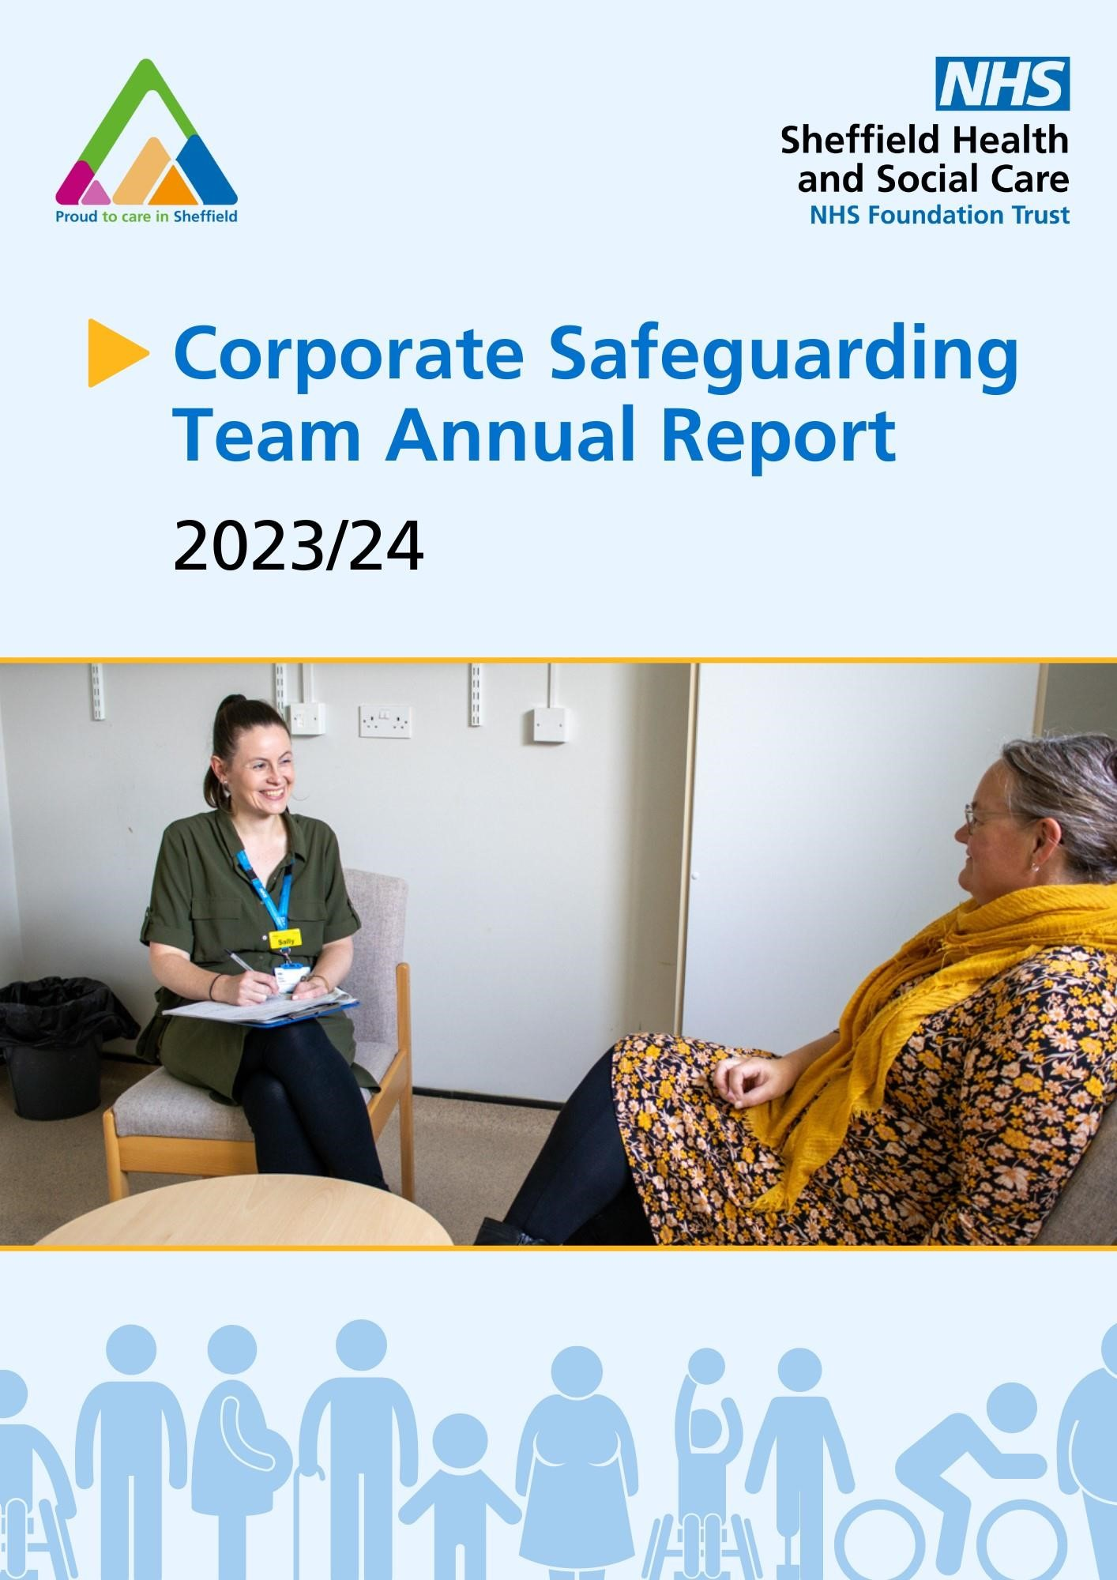

**Corporate Safeguarding Team Annual Report**

**2023- 2024**

**Safeguarding Children and Adults is everybody’s business**



**Contents**

**1.0 Introduction and Background 1.1 Team 1.2 Key Achievements 2.0 Governance Arrangements 2.1 Internal Governance and Assurance 2.2 Audit and monitoring 3.0 Safeguarding Children Practice Reviews, Safeguarding Adult Reviews, Domestic**

# Homicide Reviews

**3.1 Safeguarding Children Practice Reviews (SCPR) 3.2 Safeguarding Adult Reviews (SAR) and Serious Incident Reviews (SIR) 3.3 Domestic Homicide Reviews (DHR) 3.4 Learning from Reviews 4.0 Safeguarding Adults 4.1 Making Safeguarding Personal 4.2 Provision of staff support 4.3 Attendance at Incident Huddle 4.4 Adult Concerns Data 4.5 PREVENT 5.0 Safeguarding Children 6.0 Domestic Abuse 6.1 MARAC 6.2 MATAC**

**7.0 Multi Agency Multi Audit Group 8.0 MAPPA 9.0 VARMM & CCM 10.0 Partnerships and External Meetings 10.1 Child Death Overview Panel (CDOP)**

**10.2 Multi Agency Pregnancy Liaison Assessment Group** **MAPLAG**

**10.3 Operation Fortify (Serious and Organised Crime) 11.0 Training 12.0 Safeguarding Supervision 13.0 Risk Register 14.0 Policies and Standard Operating Procedures**

**15.0 Key Priorities for 2021/2022**

## 1.0 Introduction and Background

The Trust holds a statutory responsibility to safeguard children and adults under the Care Act

(2014) and accompanying guidance Care and Support Statutory Guidance (DoH 2016), Children Act 2004, Working Together to Safeguard Children 2018, Safeguarding Vulnerable People in the NHS, Accountability and Assurance Framework 2018 and the Children and Social care Act 2017. SHSC’s Adult Mental Health Services had delegated duties for safeguarding adults aged 18-65 who were known to be receiving SHSC services up until 31st March 2023 We aim to achieve our statutory responsibilities through:

* Providing effective, robust safeguarding policies and procedures that reflect best practice, including safe recruitment and ensuring all staff and volunteers are aware of and follow these policies and procedures.
* Delivery of safeguarding training that meets the needs of the workforce and fulfils the requirements of the intercollegiate guidance.
* Providing expert safeguarding advice and support to our workforce and embedding a model of safeguarding supervision, based on an Action Learning Set approach, for all clinical staff within the year.
* Provide data and assurance of compliance to the Trust Quality Assurance Committee and Safeguarding Children and Safeguarding Adults Partnerships.

## 1.1 Team

The team comprises of:

Head of Safeguarding – Hester Litten

Named Nurse Safeguarding Children – Angela Whiteley

Named Professional Adult Safeguarding – Laura Gould (Acting), Stephenie Barker (substantive)

2 Safeguarding Practitioners – Heather Chalmers and Laura Gould

Team Administrator – Victoria Lee

As directed by the Safeguarding, Accountability and Assurance Framework (SAAF) we also have:

Designated Safeguarding Doctor – Helen Crimlisk, Medical Director

Corporate Safeguarding Lead – Vanessa Garrity, Dept Director of Nursing and Quality

Executive Safeguarding Lead – Salli Midgeley, Exec Director of Nursing, Professions and Quality.

The Named Professional for Adult Safeguarding has been on maternity leave and due to return in

August 2024. Laura, who is one of our safeguarding practitioners has acted up into this role since July 2023. We would like to thank Laura for her hard work and commitment to this role over the past year.

The Named Professional for Adult Safeguarding is also our MARAC Lead and we have several staff across SHSC who also attend MARAC as SHSC representatives. The role is also the Prevent Lead, supported by the Head of Safeguarding.

## 1.2 Key Achievements and progress from 2022-2023

In our previous annual report, we set out the following priorities for the year ahead.

* Relaunch Safeguarding Supervision across inpatient services with a target to achieve 50% in year one for all registered professionals.
* Launch Safeguarding Supervision across the rest of the Acute and Community directorate and Rehab and Specialist with a target of all teams to have delivered/facilitated at least 2 safeguarding supervisions by December 2023



We identified that many staff were receiving forms of safeguarding supervision through debriefs and reflections and through other types of supervision. Professional intelligence identified that these important discussions were not always being recorded as safeguarding supervision. Whilst we have further work to improve formal safeguarding supervision for leaders, since data collection has moved to the Workforce Team, the data shows a rise to 82.8% compliance (based on 1163 eligible staff).

* Achieve compliance with Level 3 Safeguarding Training for Adults and Children. Target of 90% compliance across the Organisation by September 2023.



As of 14th May 2024, our Trust wide compliance was at 67.4% for Level 3

Safeguarding Children Training. Whilst this remains out of compliance, this is an improvement on previous months data. The Named Nurse Safeguarding Children alongside the Vulnerabilities Manager is leading a Recovery Plan with support

from clinical leads. Further information on this plan is detailed within the report.

Level 3 Safeguarding Adult Training is currently 86.3% compliant. This has been a month on month increase and we continue to deliver training every month.

Training sessions are fully booked and dates for the rest of year have been shared with colleagues in the training team.

* Assurances that processes, systems and responsibilities following the removal of delegated duties are clear within the Safeguarding Team and for those Teams raising a Safeguarding concern.
* Assurances through SAC that there are no delays in the LA receiving Safeguarding referrals from SHSC Trust (within 24 hours of a team raising them). This will be measured by capturing any referrals that have not been sent through to the LA within 24 hours.

Standard Operating Procedures (SOP) were completed, and relevant policies *were* updated to reflect the change in process in conjunction with regular

briefings in Connect and on Jarvis. The team also completed a short Q&A video where we discussed the changes to process and roles and responsibilities of staff. Staff are required within the SOP to share additional info if the referral requires more information. However to avoid delay, this will be submitted with advisement to the Local Authority that further info has been requested.



* The closing down of all outstanding external referrals. This will be achieved by sourcing additional temporary capacity within the team and working to a trajectory of closing down 8 referrals per day. Weekly updates to be provided to the Director of Nursing, Deputy Director of Nursing and Executive Director of Nursing and Head of Safeguarding to ensure compliance with performance.

The safeguarding team successfully closed all outstanding external referrals as part of the delegated duties in August 2023.



* Closing down of all open safeguarding concerns on Insight in preparation for the new EPR system RIO. This requires action at Team level. Weekly updates to team are in place from June 2023.

Teams were sent lists of their outstanding open SA Concerns on Insight and have been asked to ‘Exit’ the SA Concern. This is an ongoing piece of work.



**2.0 Governance Arrangements**

## 2.1 Internal Governance and Assurance

The Safeguarding Assurance Committee has been in place for two years and has a key role in holding the safeguarding team to account for the delivery of key performance indicators and wider safeguarding responsibilities, including Adult Safeguarding Assurance audit and Section 11 audits.

The quarterly reports are shared and scrutinised at the Safeguarding Assurance Committee and then presented at the Quality Assurance Committee, which is chaired by a Trust Non-Executive Director and ultimately a summary is reported into Trust Board.

Reports are written predominantly by the Head of Safeguarding and Named Nurse for Safeguarding Children with contributions from the whole team.

The safeguarding team also have a 6 weekly governance team meeting to review our audit and work plan and Terms of Reference and a standing agenda have been completed.

## 2.1 Audit and monitoring

The 2023/24 Audit was agreed and approved at the beginning of each financial year.

Safeguarding Assurance Committee (SAC) members are asked to review the team audit plan on alternate quarters with the team work plan throughout the year. A final update was provided to SAC in May 2024 at our Quarter 4 committee.

Extensive work has been completed by the Acting Named Professional for Safeguarding Adults to progress our audits around Making Safeguarding Personal. There is a tool to support staff, bite size training sessions and some good practice guidance which has been developed with CERT to ultimately improve our response and inclusion of service users throughout the safeguarding process. The MSP related audits are now complete.

We have 2 audits underway by the Named Nurse and Vulnerabilities Manager in relation to child visitors to our inpatient services. Due to lack of recording of children’s details on Insight, it has a consequence on the accuracy of data to review visits by children. The Named Nurse and Safeguarding Practitioner are considering other options to assess staff knowledge such as questionnaires and staff interviews.

We have been unable to complete 2 Audits which relate to auditing improvements that were due to be made to RIO. This delay was not expected at time of writing our annual plan and we will transfer these to our audit planner for 2024/25.

All audits were completed and the final version was presented to the Safeguarding Assurance Committee in May 2024.

## 3.0 Multi-Agency Reviews 3.1 Safeguarding Children Practice Reviews (SCPR)

Child Safeguarding Practice Reviews replace Serious Case Reviews and are conducted under the new safeguarding partnership arrangements (Working Together to Safeguard Children 2018). Part of the new process is to complete the research for potential reviews using a rapid review process. SHSC have been involved in 2 reviews in 2023-2024.

## 3.2 Safeguarding Adult Reviews (SAR) and Serious Incident Reviews (SIR)

A Safeguarding Adult Review must be conducted where “there is reasonable cause for concern about how the Safeguarding Adults Partnership, members of it or others worked together to safeguard the adult, and death or serious harm arose from actual or suspected abuse” (Care Act 2014). A review may also be commissioned in other circumstances where it is felt one would be useful, including learning from “near misses”. During the 2023-24 period there has been a further increase in the number of requests for information for SAR. SHSC provided information to the Sheffield Adult Safeguarding Partnership (SASP) for 15 cases that were considered for SAR or Serious Incident Review (SIR). This is another 50% increase on the previous year. It is notable that 8 of these cases for potential SAR were requested during Quarter 4.

2 SIR are now completed, 3 have progressed to SAR and are ongoing and 1 is newly agreed and requires allocation.

## 3.3 Domestic Homicide Reviews (DHR)

A DHR must be conducted where the death of a person aged 16 or over has, or appears to have, resulted from violence, abuse or neglect by a person to whom the victim was related or with whom the victim was or had been in an intimate personal relationship, or a member of the same household. This definition has been extended to include deaths by suicide where domestic violence has been identified. The timescale for completion of a review is approximately 6 months. Some reviews are also subject to coronial and criminal proceedings which can impact on the timescale for completion. SHSC provided information for 6 requests for consideration for DHR. 1 case was notified to the Home Office but a request has been made to de-log this following the outcome of the coroners verdict and is currently suspended, 1 case is ongoing and 1 not known to SHSC. Others are awaiting allocation of author and Terms of Reference.

All Trust DHR/SAR/SIR reports are submitted to the Deputy Director of Nursing and Director of Nursing and the Executive Director of Nursing, Quality and Professions for assurance before submission to the partnerships. All reports received following investigation through these processes are then subject to internal governance processes and approval, including the agreement of any associated action plans.

## 3.4 Learning from Reviews

Since our last report, we have updated our Safeguarding Children, Safeguarding Adults and Domestic Abuse pages on our intranet site to give staff a brief explanation of the review processes and ensure staff have easy access to all learning briefs on the SASP, SCSP and DACT websites. This is also linked internally on the Learning Hub pages. We contribute to the quarterly 'Lessons Learnt' report which is completed by the Patient Safety Specialist and shared at Quality Assurance Committee and Board.

## 4.0 Safeguarding Adults

Safeguarding duties apply to an adult who:

* has needs for care and support (whether or not the local authority is meeting any of those needs);
* and is experiencing, or at risk of, abuse or neglect;
* and as a result of those care and support needs is unable to protect themselves from either the risk of, or the experience of, abuse or neglect.

‘The local authority must make (or cause to be made) whatever enquiries it thinks necessary to enable it to decide whether any action should be taken in the adult’s case and, if so, what and by whom.’ (Care Act (DH, 2014b) Section 42 Enquiry)

SHSC strive to establish a safe environment where staff and patients recognise, report and prevent safeguarding concerns from escalating.

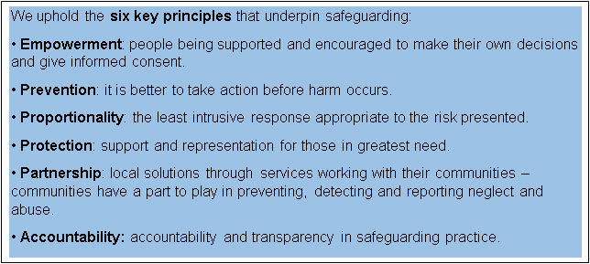

## 4.1 Making Safeguarding Personal

The Care Act 2014 emphasises that a personal approach to safeguarding is essential for making our service users feel they are the focus and have control over the safeguarding process. Making Safeguarding Personal has been a driver since the Care Act 2014. Where a person has capacity, we want to understand what outcome our service users want to enable them to feel safer. Whilst we have anecdotally identified that staff do ask questions regarding the wishes and feelings of our service users, external referrals and concerns reviewed as part of the delegated function do not evidence this approach. Templates on our Electronic Patient Record (EPR) do have questions to prompt staff to inform of a referral and it asks if the individual was “asked what their desired outcomes were?” but this prompts closed answers and no narrative about the persons wishes and feelings in line with a Making Safeguarding Personal (MSP) approach. The safeguarding team have worked with the RIO implementation team to embed the City Wide Adult Safeguarding referral form into the new EPR RIO. This will ensure consistency with our voluntary and statutory partners across the city.

In May 2023, the Named Professional for Safeguarding Adults and the two safeguarding

practitioners developed a best practice toolkit of eleven tools which were selected from the Making Safeguarding Personal toolkit handbook as being the most appropriate for the clients we work with, within the trust. These tools were developed into a PowerPoint presentation alongside an introduction to the principles of making safeguarding personal. The Community Enhancing Recovery Team (CERT) were selected as being the team which we would introduce the toolkit to initially, given they were a community-based service supporting adults with a variety of needs and this was undertaken on the 12th of May 2023. The team were supported to consider how the tools could be utilised where a safeguarding concern was identified. Discussions were held around using the toolkit as a framework for response to these, in a way that helped clients to work through what their desired outcome and the purpose of safeguarding might be, whilst maintaining focus on the needs of the individual at the centre.

The Named Professional for Safeguarding Adults and the two safeguarding practitioners additionally developed an audit tool to dip test and audited ten safeguarding concerns which had been raised by CERT prior to the toolkit delivery. The audit tool was informed by the making safeguarding personal toolkit handbook audit which is based upon principles developed with people who use services and with carers and reflect what people want from information and advice, and how they think it should be provided. The audit assessed against nineteen criteria and scored each criterion for each safeguarding concern form between 5 (absolutely meets the principle) and 1 (does not meet it at all). These figures were then adjusted to a percentage meaning that if all concerns had scored 5 for each criterion, the score would have been 100%. The audit concluded that the principles of making safeguarding personal were met at an average of 57%.

A return visit was made to CERT by the (Acting) Named Professional for Safeguarding Adults on the 2nd February 2024, following an earlier arranged visit being cancelled by the team in November 2023. The purpose of the return visit was to gather feedback on whether the tool had impacted safeguarding interventions and outcomes for their clients. The feedback was generally positive, with staff expressing that the toolkit was something they would refer to if they had a safeguarding concern for a client. Staff felt that the “What is working/not working tool” to be an easily accessible tool for clients to engage with and that this often led to an open narrative with the client being established. Staff discussed that the ability to print this tool off as a tangible, visual sheet made it easier for them to collaboratively complete this with clients. A few staff members however felt that a lack of time or reluctance from clients to openly discuss concerns, did make the toolkit difficult to embed fully. All staff members however were able to reflect and agree that the principles of making safeguarding personal were considered by them and had encouraged them to consider how to best collaboratively work with clients where there were concerns for their safety and/or wellbeing.

A further audit was undertaken to cover the period following the initial delivery of the toolkit up until the time of the return visit to CERT in February 2024. The audit concluded that the principles of making safeguarding personal were met at an average of 65%. To note, during the period audited the second time, only three safeguarding concerns were raised by CERT so this is not an entirely fair comparison to the previous audit completed when ten safeguarding concerns were available for audit data.

To support trust wide understanding of the making safeguarding personal principles and the developed toolkit, two bitesize sessions have been delivered by the (Acting) Named Professional for Safeguarding Adults in January and March this year. The toolkit has been added to the safeguarding pages on Jarvis, alongside an introduction to the principles of making safeguarding personal. A video of the toolkit presentation has also been recorded for Jarvis. However, there have been difficulties enabling this to be uploaded. The principles of making safeguarding personal have additionally been added to the Level 3 Safeguarding Adults training. It is hoped that these further actions will seek to embed the principles of making safeguarding personal into practice and will be a reminder to staff that safeguarding is a process we should be undertaking in full collaboration with our clients in a way which seeks to be open and transparent, keeping them at the centre of our decision making and interventions.

## 4.2 Provision of staff support

The Safeguarding Practitioners respond to all enquiries or requests for support and advice made by trust staff. This contact may be requested via email or telephone or Skype message. Requests vary in subject matter and can be basic requests such as support to open or exit a safeguarding form to more specialised and detailed requests for support and/or consultation.

The Safeguarding Practitioners provide support to staff to assist in the completion of DASH risk assessments, IDAS (local Domestic Abuse service) referrals and safety planning and provide review of DASH risk assessments and third-party intelligence reports prior to these referrals being sent. We additionally support staff to make appropriate and timely referrals.

Support is provided to staff in the referring into children’s and adults social care for individuals not known to the trust and practical support in the completion of relevant documentation.

We provide relevant signposting information to staff and offer specialised advice in cases where staff may have less knowledge such as for cases of cuckooing, human trafficking, and modern slavery.

In addition to quality assuring safeguarding referrals and providing advice and support to staff, the Safeguarding Practitioners attend the Multi-Agency Tasking and Co-ordination (MATAC) meeting, deputise for Multi Agency Risk Assessment Conference (MARAC) and attend the daily (Monday – Friday) incident huddles. The incident huddle is currently covered on a rotational basis by the members of the team.

The Safeguarding Practitioners attend meetings whereby it is deemed that safeguarding oversight and support is required. This includes attending Multi-Disciplinary Team meetings, Complex Case Management, and professionals’ meetings.

The Safeguarding Practitioners are now involved in delivering Safeguarding Adults Level 3 training, have delivered Bitesize training and delivered bespoke training to differing service area’s of the trust where a need for this has been identified.

## 4.3 Attendance at Incident Huddle

Incident Huddle is held Monday to Friday. This consists of representatives from the Risk Team, Safeguarding Team, Estates, Pharmacy and Physical Health Team. Incidents are sent for review prior to the meeting taking place. In huddle, all incidents that have been reported for the trust within the last 24 hours (or 72 hours on a Monday) are reviewed. The huddle representatives review the risks and identify further actions that are required.

Any incident identified to have an element of Safeguarding is discussed within the meetings and flagged to the safeguarding team to review and respond to. This will involve the safeguarding practitioners providing further review of records to ensure that the full detail is captured. Contact is made with the referrer/ward manager/matron to offer advice or suggested actions required to further safeguard. Any safeguarding concerns raised because of the Incident Huddle, are then quality assured by the safeguarding team and support is provided to manage the concern should there be an imminent risk of further harm. Following the handover of delegated duty to the Local Authority on the 1st April 2023, the safeguarding concern form is then shared to the Local Authority for their screening and action. Following the review of the incident, an update is added to the incident form to record that the incident has had safeguarding oversight and actions required.

## 4.4 Adult Concerns Data and Activity

Following the handover of our Delegated Duties on 1st April 2023, all SHSC staff submit safeguarding adult referrals to the Local Authority Adult Contact Team via the SHSC safeguarding team. Following a recent change in process and introduction of a Roles and Responsibilities guidance document from the Sheffield Adult Safeguarding Partnership (SASP), safeguarding concerns are screened by the Safeguarding Practitioner using the guidance document.

Safeguarding concerns that meet legal criteria for safeguarding will be referred to the Local Authority. Safeguarding concerns that do not meet the criteria for safeguarding will be our organisations responsibility to manage.

Following the introduction of this document, we have now revised our current processes and our SOP has been updated to reflect this. The changes required to RIO outcomes on the safeguarding concern form have been completed and the new process has been added to our Jarvis safeguarding pages and has been highlighted to all staff through our internal communication process. The SOP will be further reviewed once the new process has been in place for 4 weeks unless any issues are highlighted before this time, to ensure the processes are effectively safeguarding our service users. Additional information on the new SASP Roles and Responsibilities document can be found in Appendix 1.

All safeguarding concerns for children go to the safeguarding children’s hub in the local authority. Staff are asked to complete an incident form when completing referral to the Safeguarding

Children’s Hub. This should ensure SHSC have a record of all ‘meaningful conversations’ held with the children’s hub even if the referral is not accepted. It is envisaged that the new safeguarding children/Every Child Matters form on RIO will improve recording and remove the need for staff having to complete an incident form.

If staff have a query rather than raising a concern, they can access advice and support from the safeguarding team to discuss and consider next steps or plans to reduce risk. Due to limitations of Insight and the trusts transfer to a new Electronic Patient Record (EPR) the team do not currently monitor the activity and resource required to provide advice and suppport via telephone and email to SHSC staff and calls from external agencies. It is hoped that the new EPR will allow this function.

## Number of Adult Safeguarding Concerns raised by SHSC to the Local Authority

All of these referrals received an initial review by Safeguarding Practitioner within 24 hours of receipt to ensure accurate and adequate details is provided to assist the Adult Contact Team in their assessment. A standard operating procedure (SOP) is in place to direct staff on how to complete a referral. If there is insufficient information, a referral will be returned to the referrer with a request for clarity. It is important that all referrals also contain information on what action has already been taken to immediately safeguard the person.

# Reviewing safeguarding referrals provides a number of functions;

* it provides us with an opportunity to offer advice on actions to safeguard the person at risk,
* Request the referrer provides more detail of the concern and states what actions have already been taken to assist colleagues in MASH with their assessment.
* Able to note issues and improvements in teams and give advice and recognition.
* Supports data collection
* It also ensures that referrals are being sent securely as many of our teams and staff do not have a secure nhs.net email account.



0

0

20

40

60

80

100

120

140

Apr-22

May-22

Jun-22

Jul-22

Aug-22

Sep-22

Oct-22

Nov-22

Dec-22

Jan-23

Feb-23

Mar-23

Apr-23

May-23

Jun-23

Jul-23

Aug-23

Sep-23

Oct-23

Nov-23

Dec-23

Jan-24

Feb-24

Mar-24

**Internal Concerns Raised**

SHSC staff made a total of 828 referrals to the Local Authority during this reporting period. On a mean average, we make 207 referrals per quarter.

## Number of referrals made to Local Authority broken down for Older adults, Learning Disability and Neuro Enablement Service (LTNC)

Our previous delegated duties only applied to our working age adults and we collected data on our Older Adult, Learning Disability and LTNC service services separately. Although this responsibility has now ended, it is helpful to see referral rates from these key services.

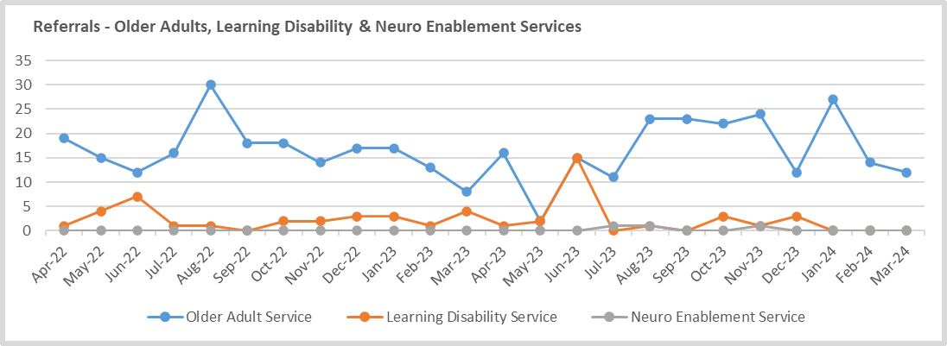

We are able to see that referral rates for Older Adults can fluctuate each month. This can be in relation to individual service users who have required multiple safeguarding concerns. The low number of referrals in our Learning Disability services reflect the loss of Firshill in 2021. We had previously identified that our Long-Term Neurological Conditions (LTNC) had no recorded referrals on our data. We discussed this with leaders in LTNC Team. The LTNC use SystmOne, not Insight and advised that they submit referrals directly to the Adult Contact Team. Whilst it is reassuring that referrals have been made, it seems to have been an error that referrals were not reported to the SHSC Safeguarding Team. Further work is required, following the introduction of the SASP Roles and Responsibilities documents, to ensure that LTNC are submitting their referrals as per the Standard Operating Procedure.

The LTNC have been sent the new SOP for Making Safeguarding Referrals.

## Section 42 Enquiries

SHSC have completed a Standard Operating procedure (SOP) for our Section 42 Enquiries and all enquiries are now quality assured via the weekly Patient Safety Overview Panel (PSOP). A S42 tracker ensures that we can adequately monitor progress of our enquiries and escalate to colleagues in the directorates where necessary. SHSC has been caused a total of 48 Section 42 Enquiries in 2023/24 which is a 54% increase on the previous year.

The vast majority of enquiries were for our acute and community directorate (36 for Acute and Community Directorate, 7 enquiries for Older Adult Services, 1 Organisational Safeguarding enquiry, 4 for Rehabilitation and Specialist Directorate). Common themes across these enquiries are in relation to neglect (self-neglect or care and treatment by SHSC), sexual safety and physical abuse (use of restriction and restraint).

Action plans are shared at the weekly investigation panel and ownership of actions lies with the relevant service with oversight from the directorate. However, this process requires further review to ensure ownership of actions. We will work with our colleagues in the risk team to explore the use of Ulysses for S42 Enquiries and actions, alongside DHR and SAR actions.

## Safeguarding Adult Concerns by Types of Abuse

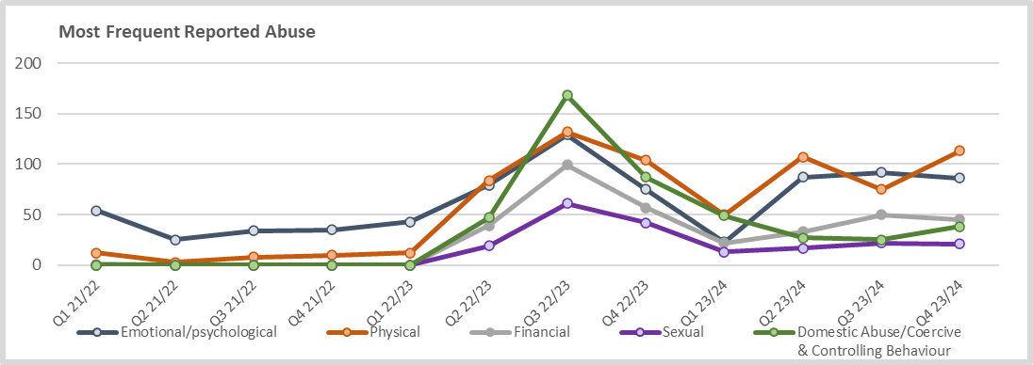

Whilst physical abuse remains the most reported cause of harm overall across the year, we continue to see positive reporting of domestic abuse and coercive control. We see this as continued improvement in the identification and response to domestic abuse. We have highlighted Coercive Control and familial violence in the review of our Domestic Abuse Policy. Bitesize training and a portion of our Adult Safeguarding Level 3 training is focussed on domestic abuse. In our reporting of types of abuse, following a referral being reviewed, a main type of abuse will be recorded as well as any other types of abuse noted of which emotional or psychological abuse is often evident.

**Notifications of Concern by Ethnicity**

|  |  |  |
| --- | --- | --- |
| **Ethnicity** | **SHSC**  **Safeguarding Referrals**  **Quarterly %** | **Sheffield Populus** |
| **White** | 56.1% | 86.7% |
| **Mixed/Multiple Ethnic Group** | 6.83% |  |
| **Asian/Asian British** | 4.66% | 8% |
| **Black/African/Caribbean/Black**  **British** | 5.37% | 3.6% |
| **Other Ethnic Group** | 2.93% | 0.7% |
| **Not Recorded** | 20.9% |  |

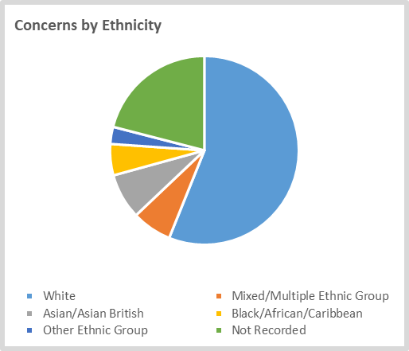

<https://www.ukpopulation.org/sheffield-population/>

Black/African/Caribbean/Black British service users remain overrepresented in our referrals compared with the overall population in Sheffield of 3.6%. Please note that we record data based on national safeguarding assurance requirements and data for the population is Sheffield is taken from the census. The census does not have data for Mixed/Multiple Ethnic Groups. In over 20% of referrals, ethnicity was not recorded. Reviews, audits, and investigations have highlighted that completion of demographic information including ethnicity requires improvement. It is envisaged that the introduction of our new Electronic Care Record, RiO, will improve recording. The disproportionate number of people from black and minority ethnicities detained under the Mental Health Act is a national concern and the rate of safeguarding concerns is higher than our service user percentage population. We have shared with data with our Patient and Carer Race Equality Framework (PCREF) Lead to understand this data more accurately.

### 4.5 PREVENT

The Adult Safeguarding Advisor is our operational Lead for Prevent and, alongside the Head of Safeguarding, attends Channel Panel on behalf of SHSC.

Prevent is part of the Government’s Counter Terrorism Strategy called “CONTEST”. As part of this strategy, all healthcare staff receive mandatory training, and this has to be updated every 3 years (training figures are contained within this report).

All staff have a responsibility to raise concerns where they believe that a service user is at risk of being drawn into terrorist activity or committing a terrorist act. Concerns are reported to the South Yorkshire Police Prevent Team. These concerns will be investigated and if felt to be appropriate the client will be offered support by the Channel Panel.

Channel Panel provides support across the country to those who may be vulnerable to being drawn into terrorism. The overall aim of the programme is early intervention and diverting people away from the risk they may face. If one of our service users is being supported by Channel, the relevant worker or team member will be invited to attend.

Channel uses existing collaboration between partners, to support individuals and protect them from being drawn into terrorism. SHSC have 100% attendance at Channel Panel this year.

**5 Safeguarding Children**

# Child Concerns Data

Throughout the reporting period, the Named Nurse for Safeguarding Children has continued to develop closer working relationships with partner agencies, promoting effective multi agency working.

The overall aim is to work seamlessly with other agencies to safeguard the children of Sheffield. To achieve this, the Named Nurse provides advice and support to SHSC clinicians around referrals to children’s services and clinicians from partnership agencies around mental health, mental health services and how to access appropriate services. The Named Nurse also works in close partnership with the Vulnerabilities Manager for SCSP who provides advice and support to SHSC clinicians on referrals to the Safeguarding Hub and other appropriate sources of support available. The graphs below demonstrate that SHSC clinicians are seeking support and advice in relation to children of our clients.

## Advice Calls Made by SHSC Services to SCSP Vulnerabilities Manager

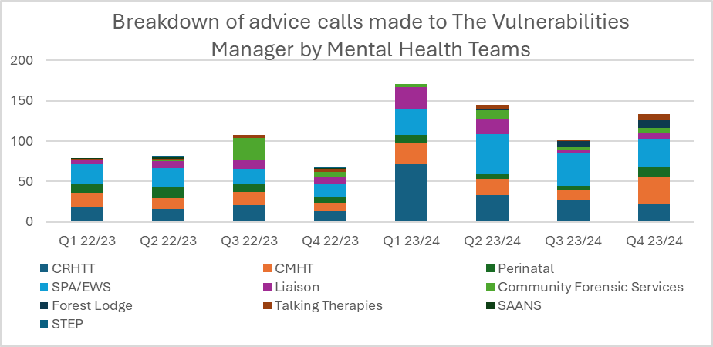

(Included within the CMHT figures are Adult and Older Adult CMHT, CERT, EIS and AOT)

There has been a significant increase in the number of calls for advice made to the Vulnerabilities

Manager over this year. There are several reasons for this. The Named Nurse and the Vulnerabilities Manager have delivered several training sessions over the past year and also provide safeguarding children supervision to several of our staff teams. Staff are therefore now aware that advice can be sought on specific cases. The other reason is that several staff members from substance misuse services returned to mental health services following the change of service provision. For these staff, it had become routine for them to seek advice and support from the Vulnerabilities Manager and they continue to do so.

SHSC clinicians attend Sheffield Children Safeguarding Partnership meetings and multiagency sub-groups.

Child Safeguarding/Protection – Identifying parents of children that are subject to child protection processes who have mental ill health and are known to SHSC. This ensures that SHSC clinicians are aware of proceedings and can participate in the process by provision of a detailed report and attendance at the Child Protection Conference. In cases where the parents have historic contact a short report is provided noting contact with SHSC services, engagement and any relevant risk factors.

This provides both; a level of support to current SHSC clients but also ensures that the safety and welfare of children at risk are a priority for SHSC. This process will continue.

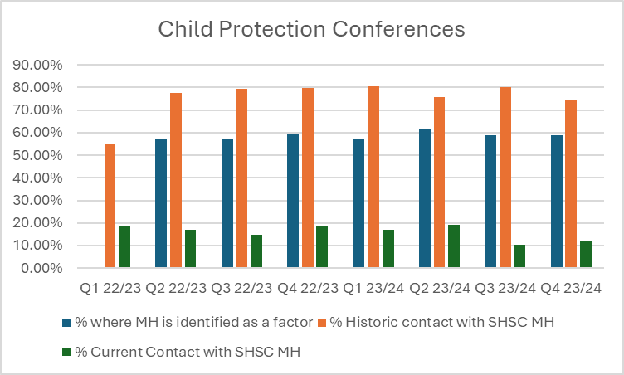

Multi Agency Safeguarding Hub – the safeguarding hub screens all referrals into Children’s Social Care. Where the referral is of a safeguarding nature the Safeguarding Hub will seek further information from partner agencies in relation to the family and support available by means of a short report. This report is completed in most cases by the Named Nurse. This report also gives the opportunity for the named nurse to provide contact information of workers in cases where one or more of the family is known and accessing mental health services. This process facilitates a multi-agency approach to working with families.

Safeguarding Children Referrals – safeguarding referrals for children are made by SHSC clinicians into the Multi Agency Safeguarding Hub by via telephone and share information referred to as a ‘meaningful conversation’. Staff complete an incident form in Ulysses to document their referrals into the Hub. This provides staff with documentation of their discussion, an audit trail to demonstrate information sharing and data to understand the number of referrals our staff are making to the Safeguarding Hub.

The process of completing an incident form in Ulysses is still not embedded. From discussion with SHSC staff, feedback suggests that the process is considered time consuming, and staff often omit to complete the incident form due to time constraints. The process continues to be promoted by the Safeguarding Team, the Named Nurse and the Vulnerabilities Manager within advice calls, training and supervision sessions. There is a combined Every Child Matters referral form that has been embedded into the new Electronic Patient Record (RIO) which replaces the need to complete an incident form. Once Rio is rolled out to all teams the documentation of referrals will be streamlined which will improve recording and audit of referrals.

**Children’s Safeguarding Referrals made to the Safeguarding Hub** *Information provided by SCSP.*

Whilst there has been an improvement in the recording of referrers details at the point of referral, ongoing audits has noted there continues to be some inaccuracies. One of the most common inaccuracies are identifying SHSC referrers as adult social care, or Sheffield Talking Therapies as private therapies. This indicates that the number of referrals by SHSC services is higher than reported.

Sheffield Talking Therapies and Crisis Resolution and Home Treatment Team have made the most referrals over this reporting period.

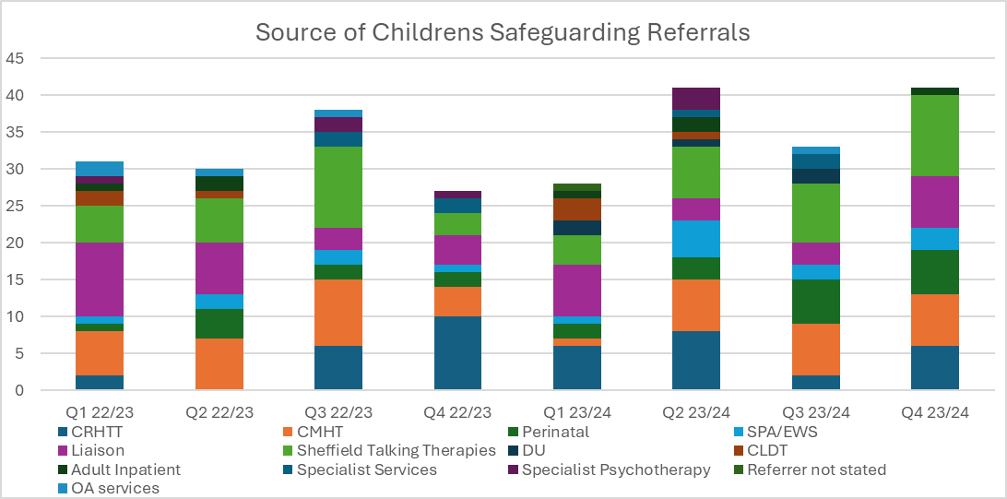

(Included within the CMHT figures are Adult CMHT, CERT, EIS and AOT. OA includes both community and inpatient services. Specialist services includes HIT Neuro case management, SCRIBT, eating disorder service, Research and development team, Adult inpatient includes Endcliffe and Forest Lodge.)

The Safeguarding Childrens Hub also record advice calls made by SHSC which can be seen below. Feedback from the Safeguarding Hub on referrals is improving although it should be noted that a large proportion of referrals made by SHSC do not meet threshold for action. The main reasons noted for this is that parents are already working with agencies to improve the situation, MASH checks had identified no concerns or adequate support was already in place.

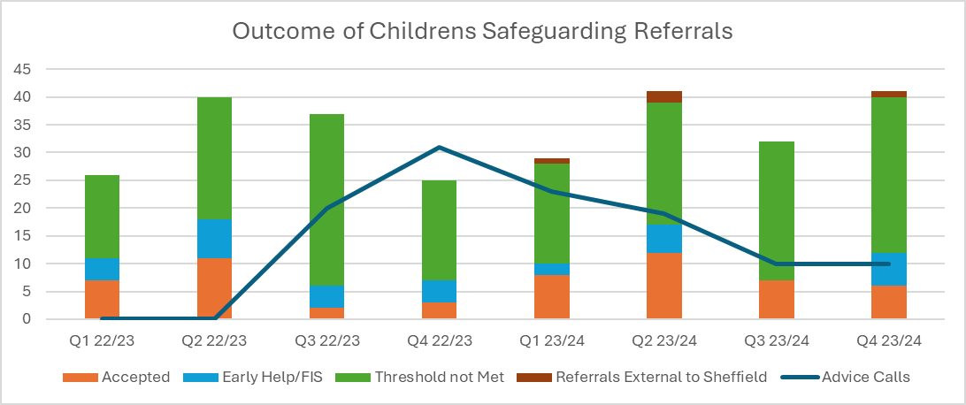

A Think Family Approach and the Contextual Safeguarding Agenda are a continuous thread running through SHSC safeguarding activity and are actively promoted by the safeguarding team. They are considered in a large proportion of the meetings and forums attended by the team and we continue to promote and embed them further within the Trust.

Learning briefs from the Parental Mental Health Group and other learning events are delivered to both SHSC staff and Children’s Social Care staff by Named Nurse and Vulnerabilities Manager for Sheffield Children Safeguarding Partnership through supervision. These promote multiagency assessment and planning meetings and include the need to look at the wider family and community when assessing needs and risk.

Strategy Discussions – A strategy discussion is held when there is reasonable cause to suspect that a child is suffering or is likely to suffer significant harm. It will involve children’s social care, the police, health, and other parties such as the referring agency. SHSC clinicians participate in Strategy discussions for families where parents are known to SHSC services. The Named Nurse has attended Strategy discussions at the request of Children’s Social Services where families are not open to SHSC services, but it is felt that mental health support may be needed or in cases where the parent/parents have previously struggled to engage with mental health services. The Named Nurse has been able to encourage engagement with services and offer signposting advice. This process will continue.

The Named Nurse for Safeguarding Children also attends and contributes to a number of multiagency meetings. See 9.0 Partnerships and External Meetings

The Named Nurse, alongside the Vulnerabilities Manager for SCSP have delivered safeguarding children case supervision within SHSC services during 2023/24 and will continue to do so in the coming year. This has been well received by staff and enables them to seek support in managing specific cases in a learning and reflective environment and facilitates learning around referral processes, child protection procedures and multiagency working. Sessions have been delivered to Early Intervention Services, Single Point of Access, Perinatal Services and Recovery Teams and Liaison, with sessions planned for the Community Learning Disabilities Team, Crisis Resolution and Home Treatment Team, Assertive Outreach Team (AOT) and Community Enhanced Recovery Team (CERT).

### 6.0 Domestic Abuse

The Domestic Abuse Act (2021) provides further protection to victims of domestic abuse and strengthen measures to tackle perpetrators. There is now a wide-ranging legal definition of domestic abuse which incorporates a range of abuse beyond physical violence, including emotional, coercive or controlling behaviour and economic abuse.

Under the Act, Police have also been given new powers including Domestic Abuse Protection

Notices, providing victims with immediate protection from abusers, whilst Courts can now issue Domestic Violence Protection Orders to help prevent offending by enforcing perpetrators to engage in support.

The Government have also added in new measures to further strengthen the law including creating a new offence of non-fatal strangulation and threats to disclose intimate images.

Other measures in the Act include extending the controlling or coercive behaviour offence to cover post separation abuse. Explicitly recognising children as victims if they see, hear or experience the effects of abuse and establishing in law the office of Domestic Abuse Commissioner and set out its functions and powers.

As an extension of the work currently being undertaken by the safeguarding team around domestic abuse, the Deputy Director of Nursing and Quality and the Acting Named Professional Adult Safeguarding have been looking to strengthen the trust response to concerns and incidents of sexual safety. We have a programme of work which is being delivered in collaboration with the people directorate because of the interrelationship between staff knowledge and confidence in dealing with sexual safety concerns and the clinical focus on responding to sexual safety incidents. We have a clear focus in our processes for reporting and responding to sexual safety incidents and this is now supported by a sexual safety dashboard which enables us to monitor sexual safety incidents at a Trust level, whilst also providing all our services with a breakdown of their incidents, so they can respond to individual concerns as well as identifying and responding to identified themes.

This also enables us to triangulate data and develop some qualitative insights into the sexual safety incidents, context and response. Whilst our priority focus is on sexual safety incidents in our inpatient settings, we have also begun work with community organisations who have expertise in sexual violence and with community organisations who work with people with 24 protected characteristics, so we can be intersectional, person centred and trauma informed in our approach and can develop a suite of resources which enable our practitioners to signpost people to specialist support as well as developing their own knowledge and skill set. The Sexual Safety work is co led by a lived experience lead who has lived experience of mental health and of accessing our mental health services at SHSC.

### 6.1 Multi Agency Risk Assessment Conference (MARAC)

The MARAC is a multi-agency meeting which takes place to discuss high risk cases of domestic abuse, including Honour Based Abuse cases.

It is designed to enhance, not replace, existing arrangements for public protection, including safeguarding children and adults, and has a specific focus on the safety of the victim and any children. The MARAC is attended by representatives from a range of agencies including police, health, child protection, housing, Independent Domestic Violence Advisors (IDVAs), probation, mental health and substance misuse and other specialists from the statutory and voluntary sectors. The MARAC functions on the collective understanding that no single agency or individual can see the complete picture of the life of a victim or is able to identify and manage the risks, but all agencies may have insights that are crucial to the persons safety and risk management plan.

The Sheffield MARAC is a full day, held every Tuesday and is led by the Named Professional Adult Safeguarding. Following the meeting, outcome and actions pertaining to risk are documented on Insight for the victims. A ‘warning’ is added to the alleged perpetrator and the victim’s record. We do not make any documentation on the alleged perpetrators Insight records as this may increase risk to the victim. We have worked with our Electronic Patient Record team to ensure Rio will provide a confidential space for MARAC documentation and an alert to note victims and perpetrators known to MARAC.

We have noticed an increase in domestic abuse and coercive control being recorded as a type of abuse. Across the year, there have been conferences on coercive control, bitesize training session on Domestic Abuse, review of the Domestic Abuse policy and we have shared learning briefings from the Domestic Abuse Co-ordination team (DACT) on our safeguarding pages. The Adult Safeguarding Advisor and practitioners encourage staff to consider domestic abuse during advice calls and this again raises staff awareness.

DASH-RIC (the documentation to refer for support and advice) are reviewed by the Named Professional Adult Safeguarding before submission. We identified that some staff were inexperienced in completing the DASH form and required support to complete. The Named Professional Adult Safeguarding ran a bitesize training session to increase awareness of MARAC and the importance of completing the DASH-RIC.

The Named Professional for Adult Safeguarding has developed a clear procedure for the MARAC process. This includes guidance on the MARAC checks; meeting preparation; SHSC referrals; presentation of the DASH; inviting SHSC referrers and documentation post MARAC, including SHSC actions. This will support staff members who cover the meetings. MARAC and completing a DASH-RIC form is included in our Level 3 Safeguarding Adult Training.

To increase our resilience and support for staff who attend MARAC, we have procured MARAC representatives training from IDAS. We have 8 staff members who have completed MARAC representative training, who are providing support and 2 further members of staff awaiting to attend the next training sessions. Once staff are trained, they will be added to the MARAC rota.

### 6.2 Multi Agency Tasking and Co-ordination (MATAC)

The Sheffield MATAC is a multi-agency meeting which provides identification and management of the most harmful serial domestic abuse perpetrators. In October 2020, the Police and Crime Commissioner for South Yorkshire and the four Local Authorities secured funding from the Home Office Domestic Abuse Perpetrator Programme Fund to adopt MATAC into existing processes within South Yorkshire. The intended overall outcome of the MATAC approach is to reduce reoffending of the most harmful and serial domestic abuse perpetrators and to safeguard victims and families. A range of interventions can be delivered via MATAC, including support, prevention, diversion, disruption, and enforcement, in order to reduce harm. This method is intended to identify harm rather than risk, where high-risk offenders are identified through other risk assessment processes.

Some of the top offenders are serial perpetrators of low-level violence to a multitude of standard risk and medium risk victims, so high levels of harm to a multitude of victims but not necessarily a high level of risk to a particular individual. However, partners do recognise that the MATAC can only have a positive impact on the MARAC by either targeting the perpetrators of those high-risk victims or focussing on those serial perpetrators and potentially preventing that escalation of violence which would lead to another high-risk victim. Running a successful MATAC process can only have a positive impact and reduce the demand on the MARAC. Currently, only perpetrators identified by the police are referred into MATAC.

A MATAC meeting takes place monthly in each Local Authority area and is chaired by the Police. It is attended by a broad range of relevant partners who are signed up to an Operating Protocol and Information Sharing Agreement. This meeting is attended by one of the safeguarding Practitioners who is currently working for the Corporate Safeguarding Team and has been attended since the end of March 2022. The team have maintained a 100% attendance at MATAC since this time.

The Acting Named Professional Adult Safeguarding has developed a clear procedure for the MATAC process. This includes guidance on the MATAC checks; meeting preparation and documentation post MATAC, including SHSC actions. This will support staff members within the safeguarding team who may provide cover for the meeting. MATAC is included in our Level 3 Safeguarding Adult Training.

The Acting Named Professional for Adult Safeguarding has developed a bitesize training session to be delivered to staff in September to increase staff awareness of this meeting, it’s objectives and link to MARAC.

### 7.0 Multi Agency Multi Audit Group

The purpose of the multi-agency case audit is to help identify what worked well, what could be improved in terms of supporting an adult at risk, and any learning that can influence future practice. This is achieved through creating a safe, supportive environment in which leaders from different service areas including SHSC can openly and honestly share their experience of involvement in the case.

The audit focuses on the person’s journey (as well as the impact on significant others in the person’s life) and collaborative working between services. A case(s) is selected for multi-agency case audit and the process requires each agency involved with the individual to complete an information gathering form and chronology. Following this, agencies meet to discuss the case including effectiveness of partnership working and to identify good practice and areas for development. Actions are then agreed and taken forward.

Adults considered for multi-agency case audit are those:

* Who are at risk of abuse and neglect.
* Will provide significant learning for partner agencies, the aim will be that cases will provide different themes and learning.
* Are receiving or should be receiving a service from a number of partners. There may be cases where an adult is not receiving a service from an agency where it appears that they potentially should be, and this will also be considered.
* Which do not meet the criteria for a SAR but there is still some learning to be had from the case. Any cases which agencies feel may meet the criteria for a SAR should still be referred using the usual SAR process.

The objective of the Multi Agency Audit Group is to highlight areas of strength and good practice for both single agencies and in partnership working; areas requiring improvement; areas of identified learning and emerging themes; to enable a culture of continuous learning and improvement, with a clear focus on what works for individuals and families; to develop a Learning

Brief and to disseminate Learning through the Sheffield Safeguarding Partnership’s (Adults and Childrens); to promote joint working: shared information, shared assessment, shared thinking and understanding, shared formulation.

The aim is to complete 3 multi-agency case audits a year including where possible, 1 jointly with Sheffield Children’s Safeguarding Partnership.

The first multi-agency audit group for “William” has been held and completed and the learning brief has been published by the Sheffield Adult Safeguarding Partnership (SASP) in March 2024.

The Multi-Agency Case Audit identified that at times there had been a lack of understanding of each agency’s roles and responsibilities and that assumptions were made due to William’s physical presentation that he did not have care and support needs.

The Multi-Agency Case Audit group recommended that a briefing focusing on self-neglect be produced which would cover some of the common myths around self-neglect and learning from the case which included detailing what self-neglect looks like; how there may be a discrepancy between how a person appears physically and their living conditions; the use of Statutory and Non-Statutory Safeguarding Enquiries and effective ways to support individuals who self-neglect.

All members of the Multi-Agency Case Audit contributed to the learning brief considering the need for this to not duplicate the self-neglect policy. This is available on our Jarvis safeguarding pages.

### 8.0 Multi Agency Public Protection Arrangements (MAPPA)

MAPPA is the process through which the police, probation and prison services work together with other agencies to assess and manage violent and sexual offenders, in order to protect the public from harm. It is a system of sharing information and combining resources to maximise the risk management in place for each individual offender. The Service Manager for Specialist Community Forensic Team represents statutory mental health services at the local MAPPA Level 2 panel every 4 weeks. Our Heads of Service attend the Level 3 meetings.

This panel is the highest localised level of inter-agency public protection and information sharing that exists. As part of this process, the representative is asked to contribute senior professional advice and guidance regarding the Mental health management and risk profile of some of our communities most dangerous members.

|  |  |
| --- | --- |
| **MAPPA Levels** | |
| Level 1 | Ordinary management where risk can be managed by lead agency (police or probation). Low to medium risk of serious harm to others. |
| Level 2 | Active multi agency management requiring regular meetings. High or Very high risk of harm to others. |
| Level 3 | Active enhanced multi agency management, reserved for those deemed to pose the highest risk of causing serious harm or whose management is problematic |

|  |  |
| --- | --- |
| **MAPPA Categories** | |
| Category 1 | Registered sexual offender |
| Category 2 | An offender convicted under the Criminal Justice Act 2003 who has been either been; sentenced to 12 months or more in custody, sentenced to 12 months or more in custody and is transferred to hospital under section 44/49 of MHA, or detained in hospital under section 37 of MHA |
| Category 3 | A person cautioned or convicted under Criminal Justice Act 2003 for an offence which indicates they are capable of causing serious harm |

## Data for Sheffield

### SHSC MAPPA Community Clients as at 31 March 2024

Area South Yorks

|  |  |  |  |  |  |
| --- | --- | --- | --- | --- | --- |
|  | Level |  | |  |  |
| Category | Level 1 | Level 2 | Level 3 | Level not set yet | Grand Total |
| 1 | 15 | 16 |  |  | 31 |
| 2 | 30 | 17 | 1 |  | 48 |
| 3 | 2 | 15 | 1 | 1 | 19 |
| Grand Total | 47 | 48 | 2 | 1 | 98 |

#### 9.0 Vulnerable Adults Risk Management Model (VARMM) and Complex Case Management (CCM)

VARMM is the Vulnerable Adult Risk Management Model, a multi-agency process which helps manage complex high-risk cases where the person is considered to be at significant risk of serious harm/death through self-neglect and poor engagement with services. SHSC staff use the Multi Agency Self-Neglect Policy and Practice Guidance (Including VARM and CCM). All service users that are subject to VARMM will have had a safeguarding concern raised and VARMM will have been a suggested outcome of the concern.

#### 10.0 Partnerships and External Meetings

The Head of Safeguarding, Named Nurse for Safeguarding Children and Adult Safeguarding Advisor attend a variety of external meetings.

* Vulnerable Adults Panel (VAP)
* Multi-Agency Risk Assessment Conference (MARAC)
* Channel Panel
* Prevent Silver Group
* Domestic and Sexual Abuse Provider Consultation Group
* Safeguarding Adults and Children Health Reference Group
* Sheffield Adult Safeguarding Partnership (SASP) Performance and Quality Meeting
* Sheffield Safeguarding Children Learning and Practice Improvement Group (LPIG)
* Multi-Agency Pregnancy Liaison and Assessment Group (MAPLAG)
* Parental Mental Ill Health Task/Finish Group
* Operation Fortify Silver and Bronze
* Vulnerable Young People’s Executive Board
* Multi Agency Audit Group
* City Wide Best Practice Group
* Adult Health Reference Group
* Hidden Harm
* Domestic Abuse Children and Young People as Victims Group

We value our work with the Sheffield Adults and Children’s Safeguarding Partnerships and these relationships. We continue to attend and participate in partnership groups.

#### 10.1 Child Death Overview Panel (CDOP)

Sheffield is part of the South Yorkshire Child Death Overview Panel.

The CDOP reviews all child deaths that occur within the Sheffield area. The purpose of CDOP is to collect, collate and analyse data from all child deaths to determine any contributory factors and identify any learning that may prevent future child deaths both locally and nationally. It will also highlight any death as a result of abuse and/or neglect. The last report for 2021-2022 can be found here : <https://www.safeguardingsheffieldchildren.org/assets/1/sycdop_annual_report_2021-22.pdf>

The Safeguarding Team continue to provide information to the Child Death Overview Panel relating to close family members of the deceased child. This is provided by means of a short report. This information is limited to any recent contact. Child death reviews are held for all partners that have had significant contact with the child or family.

#### 10.2 Multi Agency Pregnancy Liaison Assessment Group MAPLAG

Multi Agency Pregnancy Liaison Assessment Group is a Safeguarding Children Group who meet and discuss issues around women and their partners who experience difficulties with drug and alcohol use in pregnancy. The meeting focuses on sharing of information and assessment of risk enabling core agencies to agree appropriate interventions. The aim of the group is to ensure that right support package is offered to women and their unborn babies.

Staff from SHSC Perinatal Service attend MAPLAG on a regular basis. In cases where the either of the parents is receiving a service from SHSC the allocated worker is asked to attend. The Safeguarding Team provide relevant information pertaining to engagement and risk factors for any parent that is either open to SHSC services or has had historic contact with SHSC services.

#### 10.3 Operation Fortify (Serious and Organised Crime)

SHSC Safeguarding team attends Silver and Bronze Fortify meetings and contributes valuable information to enable the reduction and disruption of Serious Organised Crime (SOC). SHSC sees service users admitted onto our inpatient wards and Health Based Place of Safety (Section 136) who are involved in gang activity. Children and Young People who have been exploited attend the Emergency Department at NGH and this can result in contact with our Liaison Psychiatry team. Our Street Triage team are also potential points of contact with people at risk of gang violence and criminal exploitation.

**11 Training** One of the most important principles of safeguarding is that it is everyone’s responsibility. Sheffield Health and Social Care (SHSC) staff frequently work with people in their moments of greatest need and can witness health and social inequalities which have a direct impact on the lives of people they care for. To protect adults, children and young people from harm, and help improve their wellbeing, all SHSC employees are required to have the competencies necessary to recognise adult and child maltreatment, the opportunities to improve wellbeing, and the knowledge necessary to take effective action as appropriate to their role. The Adult[1] and Children’s[2] Safeguarding Intercollegiate documents provide a clear framework which identifies the required competencies. Levels 1-3 relate to different occupational groups, while level 4 and 5 are related to specific roles. PREVENT training should be accessed at Levels 1-33. There is specific training at Level 3 for those working in Mental Health.

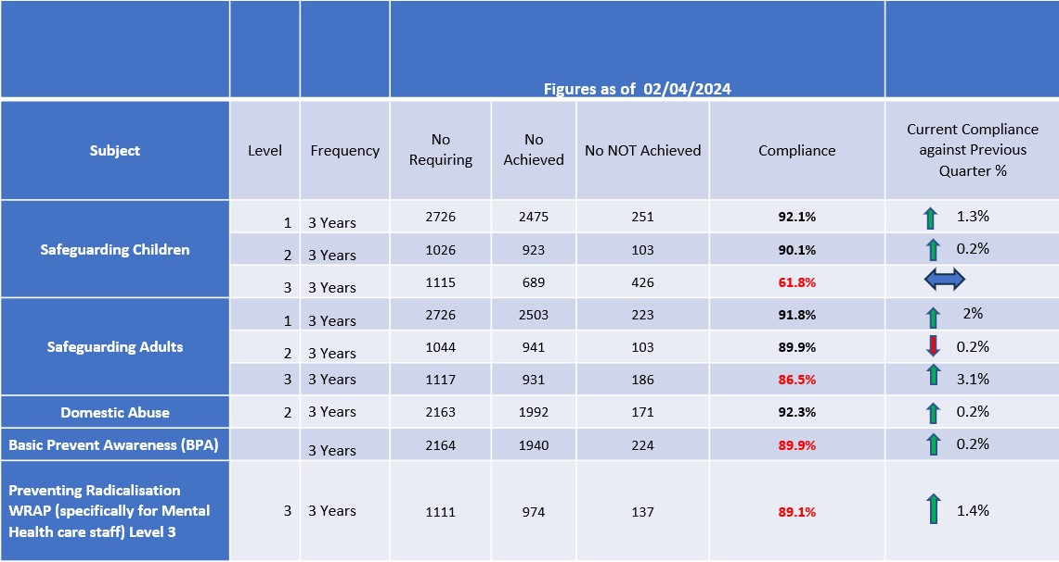

Figures above were shared with the Safeguarding Assurance Committee in May. In April, Safeguarding Adult L2 and Basic Prevent Awareness training dipped by 0.01% however this has since improved, and we are compliant across all areas of Level 1 and 2 Adults and Children safeguarding training, Basic Prevent Awareness and Domestic Abuse training which offers assurance that staff have completed training to recognise and respond to abuse.

### Safeguarding Adult Level 3 Training

This training was introduced in April 2022 and we have now reached over 86% compliance. The courses are run each month and are full until the end of June, with further dates now available for the rest of the calendar year.

Compliance is monitored quarterly via the Safeguarding Assurance Committee. The training has received very positive feedback. It is of an excellent standard and covers all of the 99 competencies required for registered professionals at Level 3. The training also includes Domestic Abuse, Coercive Control and Modern Slavery and cuckooing has been added more recently. Compliance for Safeguarding Adults Level 3 has increased month on month.

### Safeguarding Children Level 3 Training

Safeguarding Children Level 3 Training compliance remains non-compliant. SHSC is the highest attender of SCSP training, and the Local Authority have confirmed that there are adequate number of spaces for staff to attend. We know there are a number of staff who remain non-compliant and are not booking onto available training.

From January 2024, attendance has been closely monitored by the Named Nurse. It can be evidenced that staff for whom compliance is not required are attending for professional interest, and others are booking on numerous courses which will ensure their compliance for the next 2-3 years but has little impact on current compliance figures.

Feedback from teams is that they find booking via an external source difficult to navigate. A recovery plan has been developed this year which has seen the introduction of Task and Finish Groups. These groups aim to identify difficulties faced by teams and assist them in overcoming these difficulties. The recovery plan includes the following.

* Extra training sessions to be provided by Named Nurse and Vulnerabilities Manager that are bookable internally, to try and address some of the difficulties reported by teams. These training sessions will continue throughout 2024/25.
* Information on Jarvis has been updated with regards to requirements of compliance with safeguarding children’s level 3 training.
* A review is to be undertaken of the mandatory training matrix to ensure that staff members have the correct mandatory training identified.
* Training workshop flyers to be sent to all teams.
* Contact to be made with individual staff members and their manager to encourage compliance.
* Managers have been asked to ensure preceptorship nurses are booked onto training whilst supernumerary to reduce the impact of service delivery.
* Ongoing monitoring of attendance at training.
* Task and Finish Groups to continue.

The team has continued to deliver or procure safeguarding training in our monthly bitesize training events. These can be short 30 minutes sessions to share new processes or changes to policy or can be up to 2 hours on a specialist topic. Dates are set and booked throughout 2024. Information has been put on our Jarvis pages and circulated to managers.

### Prevent

Level 3 E-Learning - Preventing Radicalisation (specifically for Mental Health care staff) is now on ESR for all registered professionals. As of 14th May 2024 we are now also compliant with this training at 90.5%.

#### 12 Safeguarding Supervision

SHSC has a standalone Safeguarding Supervision Policy which was ratified in November 2021. Attendance at all forms of supervision should be recorded using the supervision dashboard. Safeguarding Supervision data is monitored via the Safeguarding Assurance Committee. The model is based on an Action Learning approach and seeks to ensure staff have a dedicated safe space with peers and a facilitator that promotes learning and reflection. The policy uses a cascade model whereby the Corporate Safeguarding Team supervise Safeguarding Managers and Safeguarding Managers supervise staff groups.

We identified that many staff were receiving forms of safeguarding supervision through debriefs and reflections and through other types of supervision. Professional intelligence identified that these important discussions were not always being recorded as safeguarding supervision. Whilst we have further work to improve formal safeguarding supervision for leaders, since data collection has moved to Workforce Team, the data shows a rise to 82.8% compliance (based on 1163 eligible staff).

Staff are required to attend 4 sessions per year and can attend either a group or 1-1 session. 1 session per year must be face to face. In addition to this, the Vulnerabilities Manager and Named Nurse are delivering sessions to a number of our services across SHSC. The sessions have given staff the opportunity to ask questions about safeguarding children, case discussion and advice and can offer updates on existing cases. The response to these sessions continues to be positive and is an opportunity to support staff to book on L3 Safeguarding Children training and help staff reflect on a Think Family approach.

|  |  |  |
| --- | --- | --- |
|  |  |  |
|  | **No of Registered Professionals receiving safeguarding supervision** | **% No of staff who have attended supervision this quarter** |
| **Q4 (2023)** | 252 | 23.1% (based on 1090  eligible staff) |
| **Q1 (2023)** | 240 | 22% (based on 1104  eligible staff) |
| **Q2 (2023)** | 276 | 25% (based on 1102  eligible staff) |
| **Q3 (2024)** | 862 | 69.8% (based on 1234  eligible staff) |
| **Q4 (2024)** | 963 | 82.8% (based on 1163  eligible staff) |

##### 13.0 Risk Register

**The Safeguarding Team have 1 risk on the Corporate Risk register.**

**Directorate Risk 5274** SHSC is not currently compliant with Safeguarding Children Level 3

Training as set out by the NHS Intercollegiate document for Safeguarding Children and Young People. There is a risk that staff will fail to identify, act upon, report and manage safeguarding children concerns in their line of duty which could result in harm to children and young people.

The Named Nurse Safeguarding Children has initiated a Task and Finish Group and written a Recovery Plan to improve our Trust wide compliance. The Recovery Plan was shared with the Safeguarding Assurance Committee and will continue to be monitored through this group.

Appropriate training has and continues to be promoted amongst SHSC staff via JARVIS,

Communications, Workforce, via safeguarding children’s supervision and by direct communication with Team Managers and individual staff members.

There are a sufficient number of courses available which cover a wide variety of topics that meet the requirement of level 3 Safeguarding Children training. A recent review of course subjects saw the introduction of further courses being added, some of these were aimed at specific staff groups (e.g. Older Adult domestic abuse).

Safeguarding Children Level 3 Task and Finish Groups have been commenced. Our next steps are to continue to promote appropriate training via JARVIS, Workforce and safeguarding children supervision. There will be direct communication with Team leaders with course availability and courses of particular interest to their client groups and the Named Nurse is requesting regular lists of all non-compliant staff so individual emails to be sent to all with Workshop Flyer with team managers copied in. Further training is being delivered by Named Nurse and Vulnerabilities Manager.

#### 14. Policies and Standard Operating Procedures

All SHSC policies and SOP’s relating to safeguarding are within date. Although the Allegations Against Staff Policy was in date, we reviewed this support from an Expert by Experience to strengthen the support for service users. This was ratified at Policy Governance Group in May 2024.

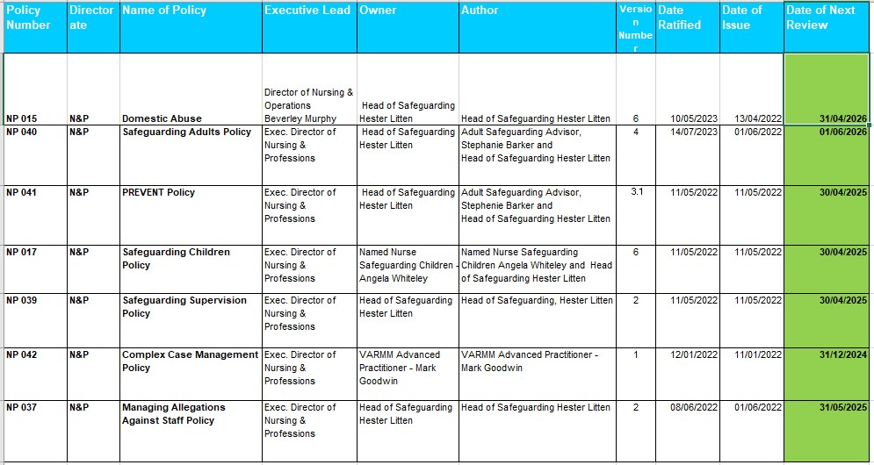

##### 15.0 Key Priorities for 2024-25

* Implementation and monitoring of the new Sheffield Adult Safeguarding Partnership (SASP) Roles and Responsibilities document to ensure referrals are being actioned internally and shared with Adult Social Care as per guidance.
* Ensure we are using Ulysses to its’ full potential to report and record DHR, SAR and Section 42 Enquiries where possible.
  + Transfer any open/ongoing DHR and SAR action plans to Ulysses to ensure robust monitoring of actions.
  + Upload all new SAR and DHR consideration requests to Ulysses to improve transparency and clarity of the process and stages of each investigation.
* Complete and publish our Service User Patient Incident leaflet that has been co-produced with our Expert by Experience.
* Sexual Safety is one of our Key Quality and Safeguarding objectives.
* We are having a spotlight on women who are admitted to our acute inpatient services during pregnancy, where they are not able to access the regional inpatient perinatal service.
* We will work to collect accurate data surrounding ethnicity of our service users and safeguarding referrals and analyse this data with the PCREF Lead.

1. Adult Safeguarding: Roles and Competencies for Health Care Staff | Royal College of Nursing (rcn.org.uk)
2. Safeguarding Children and Young People: Roles and Competencies for Healthcare Staff | Royal College of Nursing (rcn.org.uk) 3 [prevent-training-competencies-framework-v3.pdf (england.nhs.uk)](https://www.england.nhs.uk/wp-content/uploads/2017/10/prevent-training-competencies-framework-v3.pdf) 