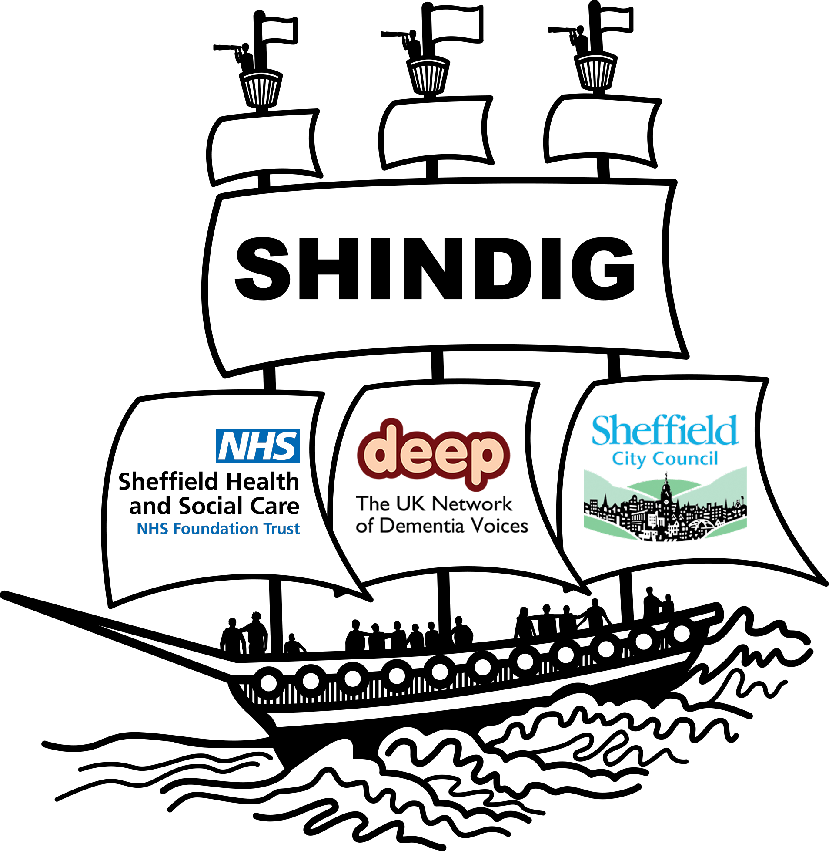

Sheffield Dementia Involvement Group

May 5th 2022

Technology to enhance living

Background
The topic for SHINDIG this quarter resulted from two things. A request from the Dementia Strategy Group to explore what types of technology people living with Dementia are currently using. Along with a theme that comes up frequently in SHINDIG discussions ‘living well with Dementia’. We wanted To find out how people are using technology in their daily lives and what influences their choices.
In May we were joined by 15 people living with Dementia, 7 people with a dementia diagnosis and 6 carers. Among the group were 3 new members, 2 recently recruited from SADACCA Sheffield and District African Caribbean Community Association. Another person, previously involved in SHINDIG had learned via word of mouth that we had returned to face to face meetings. There were 6 facilitators and 9 guests. A number of organisations were contacted in advance in attempt to make this SHINDIG an interactive experience.
In attendance we had:
Playlist for life: Emma Aspinal Leary
Sheffield Hallam University (Dementia friendly apps) Phil Jodrill
Octagon Arcade and Music Box: Justin Christianson and Jonathon Pigrem
Otiom Tracker/Monitoring App: Liana Danby
Emma gave a brief presentation on Playlist for Life at the start of the afternoon. Although this demonstrated a really good resource. The film footage shared was felt to depict people living with Dementia as rather frail and passive. Having the playlists created for them rather than being encouraged to do them while still able to do so independantly. Feedback will be provided on this.
After splitting into three groups, each group explored an example of technology brought by our guests then entered into discussions about use of technology in general.
SHINDIG continues to attract a range of professionals and students and we are actively building links by ‘dropping anchor’ to spread the word and initiate conversations. Information shared in this report also includes what we learned by attending a ‘well being’ group at Hillsborough Park. In order to generate discussion at Hillsborough we tried using images mounted on card of different examples of technology. The group paid little attention to the images on this occasion. However we will try this approach again along with the use of objects to generate discussion. The reason for this is an attempt to engage all our members as fully as possible. Some people may respond better to visual cues.

Summary

- Technology needs to have a purpose be that practical or pleasurable.
- SHINDIG attendees learn from eachother
- People often favour familiarity and shared experiences generated by technology.
- Alexa devices are extemely popular and easy to use.
- Cost remains a factor and renting or being issued devices like Alexa would be welcomed.
- When is the right time to accept technology which could keep you safe?
- Should Health Care Professionals initiate difficult discussions rather than family members?
- Consideration needs to be given when introducing technolgy to prevent confusion or people feeling patronised.
- People are keen to learn about technology and different devices but don’t know where to go.
- People living with Dementia are currently using technology for the following
- Learning new skills
- Health and Leisure
- Keeping in touch
- Staying safe and practical purposes

Main Report
Two of the SHINDIG groups were influenced by the playlist for life presentation which resulted in spontaneous ‘sing alongs’ prior to discussions taking place. A new member launched into the song ‘Slow boat to China’ which others recognised and joined in. This led to a period of reminiscing.
“Takes you back, brings tears to your eyes”
Instruments to aid engagement with music
People were invited to explore the two devices one had buttons to press the other, a handle to turn. Different rhythms, tones and frequencies of repetitive beats were generated. There were no instructions or indications of what each button does.
The group engaged with the instruments for brief periods. The majority seemed rather confused by them but offered opinion on how they felt they could be improved or used.
“I am mystified as to what we are trying to achieve. If you were using it in a group, perhaps if it were smaller, you could pass it around and each person could take turns to press another button”.
“It reminds me of a simple version of an electronic keyboard that you can use to set off different tunes and different instruments. I never cottoned on to what pushing the buttons was trying to achieve”.
It seemed important for people to feel some sense of purpose and familiarity when ‘making music’.
“If it could be used to build up and create a tune or melody it would be more meaningful. I was trying to build a tune up”.
“I thought I was doing it wrong”.
When asked directly for an opinion on the instruments a person with advanced Dementia stated several times
“Nothing much…rubbish”.
Another person echoed this
“I didn’t enjoy it; I didn’t know why I was doing it. It was better when we were having a singsong”.
One carer felt that these instruments would have been too complicated for her husband acknowledging that it depends at what stage a person is at.
“I think it would be confusing for someone with dementia depending on the severity”.
Another person was rather intrigued by the instruments and sounds being created. Appearing to enjoy the experimental approach,
“There is something exciting about it, you could have fun speeding it up and slowing it down”.
No-one felt they would use these instruments themselves but felt children may enjoy them. It was suggested that the instruments may be best used on a
one-to- one basis. This led to a discussion our emotional responses to music and the importance of this.
“Sometimes there are sad associations, experiences that elicit tears can be valuable. It is not necessarily negative. Happy tears can be good”.

OTIOM
A monitoring app for individuals living with Dementia which aims to promote independence. A waterproof device which can be sewn into garments. Can be customised to meet individual needs. Uses GPS and Bluetooth to track. Time limits can be set which result in alerts should a person go out of a set boundary. Receiver would be alerted via phone/tablet by text message.
Opinions on OTIOM
Some people felt that a tracker was a good idea, but all stressed it was something they may use in the future. Acknowledging things will change but also indicating they are not ready to accept such technology yet. This was echoed in the group at Hillsborough Park.
“Sounds really good for the right person may be beneficial in two or three years”.
There was discussion on the use of tracking apps on mobile phones to keep in touch with all members of the family. Particularly teenagers.
Cost was an important factor and people were surprised at the price, even the rental option. The group acknowledged the cost of living increasing and one person indicated she had other priorities.
“Very expensive on top of existing care costs, there are cheaper alternatives”
“It’s costing more to live now and go out in the community; people may struggle to pay for Otiom”
“£30 a month that is the same as two bottles of Baileys, I love my Baileys”
For one person the idea of ‘being tracked’ was disturbing.
“I would hate to be tracked, however family members would like it”
A conversation then took place about ‘mental capacity’ and if it was right to go ahead with a tracking device if the person lacked capacity to agree to it. The group acknowledged that it is important to do what is in the ‘best interests’ of the person living with Dementia. One carer spoke about it being difficult to have such discussions with their relative and felt it was best for health care professionals to make such recommendations.
“It is so hard to bring up these sorts of things with her, It would be better if the person had these discussions with HCP’s”.
The group passed the device around and all agreed it could be worn discreetly but some felt it could get lost easily.
Acknowledging the cost, one carer enquired
“Could it be re-used, say if the person passed away”
The device can be reset and re-used.
Ipad’s Apps designed for people living with Dementia
People were familiar with using an iPad and tablets for leisure but also for practical purposes.
“Using technology can help fill in gaps”.
One carer indicated the value of having an iPad in terms of managing her own wellbeing.
“I love my iPad as it helps me to switch off”
People felt the choice of app should suit the individual, there was mixed opinion on those presented to the group.
“I love it, apps might be good if you get the right one for the person and catch them at the right time, it’s always worth revisiting”.
“It is finding the right balance some too hard some patronising and childlike”
One person recently diagnosed acknowledged his own recent experiences.
“I personally struggle to concentrate on games now however my granddaughter had a keyboard on a tablet it gives you prompts and is very engaging”.
One person didn’t really enjoy using the iPad, his wife explained that he is a very ‘hands on man’ and this wasn’t ‘his thing’.
There was an interest to explore using tablets and apps and one person suggested renting tablets rather than having to purchase them.
What technology do you already use?
Most people were familiar with or used Alexa devices in the home. A few sought more information and existing users explained the potential of such a device. One couple shared how they both benefit from the introduction of Alexa into the home.
“We use Alexa for playing music my wife has been able to tell Alexa what she wants to listen to. We have a regular daily routine. I can leave her listening to music while I do the housework or gardening. 10am Cliff Richard, 10:30am Nat King Cole, 11am Gerry and the Pacemakers”.
“When I’m feeling down in the dumps, I will ask Alexa to play country music”
Another person shared how she uses Alexa and dances around the house while doing chores. A further person listed some of the practical uses for Alexa.
“Alexa is very good it has multiple purposes; you can set it to turn the lights on and off or call for help in an emergency. It’s great for spelling and reminders apparently you can change the name. You can get an Alexa with a digital clock”.
At the group in Hillsborough Park each person was invited to share their song choice and engage with Alexa directly. One man after asking for ‘My way’ by Frank Sinatra continued to stand and sang the whole song along with Frank, beaming from ear to ear. His daughter entered mid-way and became quite emotional. There is something valuable about the immediate response you get from technology like Alexa which can enable spontaneous activity like this.
Learning new skills
Amongst SHINDIG members was a genuine interest to learn about technology. Particularly that which had a practical purpose or could aid them to share their story.
“I would like to write a blog my stories about minor miracles, but I don’t know how to go about it I could do with learning. I am willing to learn if someone could tell me how to do it”.
Another person living with Dementia shared in a very humorous manner her dislike of technology. However, she was willing to listen to tips from peers to help her achieve a significant goal. A physical condition was impacting her ability to record information.
“I am not using a computer at all; I don’t like being tracked or followed. Recently I stopped using my phone for a while. I think I’m going to vanish off the face of the earth if I don’t change my ways. I’m writing a bit of family history but struggling”.
Appropriate advise was provided.
“You can dictate to a computer, and it will record your words as text. Sending things in PDF format helps people with Dementia as the content can be shared aloud. It also benefits other people as well”.
A new member took the opportunity to seek advise on how she could condense cd’s and find a remote control that her husband would be able to operate.
Health and Leisure
One person shared his approach to managing his health.
“I use the internet to research into my condition and see what I can do for myself”.
Others shared using a virtual approach for various leisure pursuits
“I use audio books to have some time out and find it easier than reading and losing my place”.
Two people used YouTube on a regular basis to access exercise classes and lessons on activities like keep fit, knitting, ballet and playing ukulele
One member of the group shared his involvement with Deepness Radio and how this offers tools to promote wellbeing.
“You can listen to relaxation on our radio station, Deepness radio was set up by and is run by people living with Dementia”

Keeping in touch
People continue to use a virtual approach to keep in touch and listed Face Book and Face Time as ways of doing this. Although most prefer meeting face to face, people do recognise the benefits of a virtual approach especially if family are far away or groups are hard to travel to.
“We use it to socialise and keep in touch, so we know what the kids are doing”.
A discussion took place around the use of photographs stored on phones. Something often done to aid reminiscence or in attempt to trigger a positive response. One person living with Dementia stressed the need to:
“Know a person’s history, as some people may become upset by seeing photos, this could remind them of a past trauma”.
Practical use
Several people used technology at home to keep them safe, for security purposes and to alert others in case of emergency. Some people were wearing, pendants or bracelets. One person mentioned managing finances and using a banking app to make payments. Mobile phones were used for directions and
reassuring family members.
“My son provides me with this phone when I’m going out. He phones me if he’s worried. I sometimes can’t hear it in my bag. I do use it for taxis though”.
Another person spoke about the process of getting a new passport and was amazed how technology speeded up the process.
“Oh, my goodness, he only took my photograph two minutes ago and it’s already up there on the computer screen. It’s amazing what happens these days”.
Conclusion
This SHINDIG enabled people living with Dementia and carers the opportunity to explore a small selection of technology and share their opinion of it. People where asked what technology they already used and conversations emerged which demonstrated how technology currently influences the following areas for this group:
Learning new skills
Health and Leisure
Keeping in touch
Staying safe
To see the apps explored in our May SHINDIG please search for the website below
www.actodementia.com
For further information about SHINDIG please feel free to contact
Claire Jepson
SHINDIG Coordinator
claire.jepson@shsc.nhs.uk
For past reports go to www.shsc.nhs.uk/shindig
Telephone number: 07974595052

