 | My Positive Behaviour  Support Plan

 | This is my care plan. It is about me and my health and wellbeing.  [ ] It shares my ideas and opinions on my care.  [ ] It is written in my best interests by those who know me.

 | This plan is private.  You must ask me before you read it.  It is my choice.  I can say yes or no.

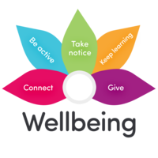 | My care plan tells me about my health and emotional support needs.  My care plan tells me about the support I will receive to stay safe and well.

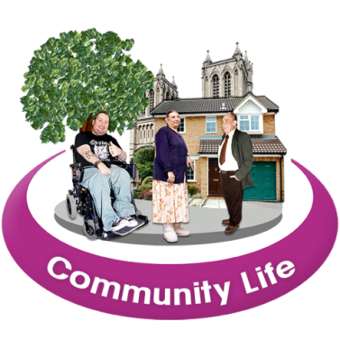 | This plan contains my wishes for the future.  This plan describes what I want from life.  It is about the daily support I need to be well and live a safe and happy life

 | All About Me

Photo | Name:  Date of Birth:  Address:

   | Background Information:

 | Things I like:

 | Things I do not like:

 | Religion/beliefs:

 | My Supporters

These people will all work together to help me.
Parent/Carer

Family Member
???

Social Worker

CPA Coordinator

Health Professional
???

Health Professional
????

Health Professional???

Parent/Carer

Name

 | My Good Day

 | My morning routine:
 | My meals:
 | My activities:  In the morning I like to….  In the afternoon I like to ….
 | Helping me to relax:
 | My trips out:
 | My bedtime routine:

 | My Health and Care Needs

 | Important health issues for me are:

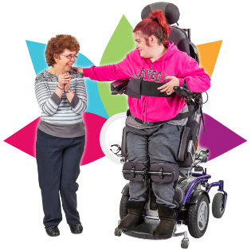 | I have the following physical health needs:

 | I have the following communication needs:

 | I have the following sensory needs:

 | I have the following additional needs:

 | What positive life skills or support will help me enjoy a better quality of life?

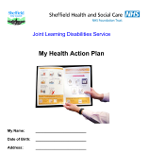 | I have a Heath Passport and Health Action Plan.  These say what needs to happen to keep me well.  Please read this document.

 | Assessment of Behaviour

 | The behaviour that places me or others at risk is:

 | Activities:  Places:  Times of Day:  Other people:

 | Things I find difficult/my triggers:

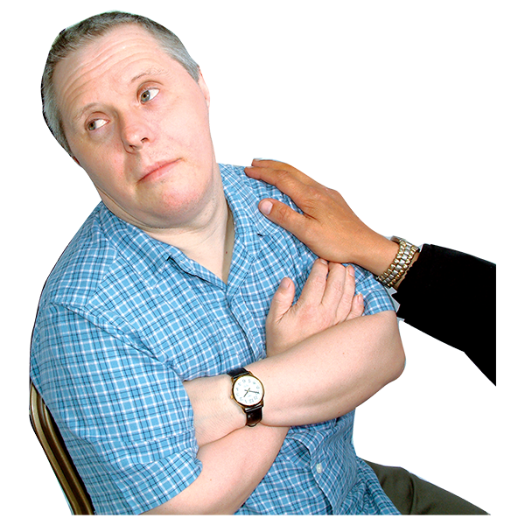 | What functions (e.g., attention, escape, sensory, access to an object, expression of an internal emotional state/pain) does the behaviour serve for me?

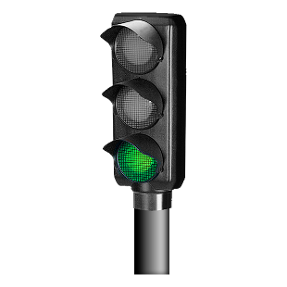 | When I am doing well, you will see:
What helps and how to support me:

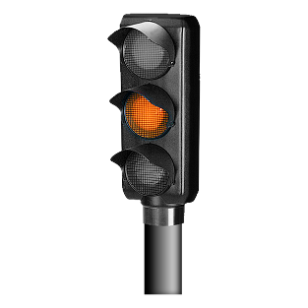 | When I am becoming unsettled, you will see:
What helps and how to support me:

 | When I am in crisis, you will see:
What helps and how to support me:

 | After an incident, you will see:
What helps and how to support me:

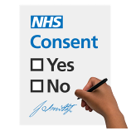 | Consent & Capacity

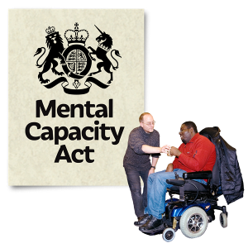 | Check the person understands the content of this plan before they are asked to sign it.  If the person cannot understand the plan, please use MCA paperwork to record the assessment of capacity and best interest decision making. Consider Deprivation of Liberty assessment and safeguards where appropriate.

 | Name of professionals who have contributed to this plan?
 | Has this person got capacity to consent to this plan?
 | If yes, do they consent?
 | If the person does not have capacity, are you making this plan in their best interests?

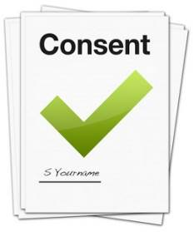 | I agree with the use of this plan
 | Signed: …………………………..……………… | Date: ………………

   | This plan will require updating by the staff team involved in the individual’s care.  This should be reviewed at least every three months and also when there are any changes to an individual’s care or needs.  Always look to reduce restrictions where safe to do so.  If you have any concerns about this plan, or changes in behaviour or care needs, please contact the Community Learning Disability Team.  Telephone: 0114 2261562  Email: cldtbusinesssupport@shsc.nhs.uk  Web: https://www.shsc.nhs.uk/services/community-learning-disability-team

