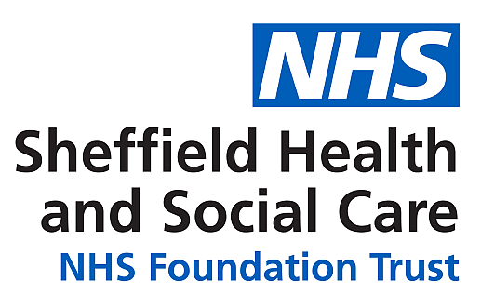

Access to Health Records Information Sheet for Patients/ Applicants Under:
- Data Protection Act 2018
- UK General Data Protection Regulation (UK GDPR)
- Access to Health Records 1990 (deceased patients only)

Background to the Regulation
Data Protection Law gives individuals a right to access their personal health records.

People who can apply include the patient / service user about whom the records have been compiled or a person acting on their behalf.

The Access to Health Records Act 1990 allows the personal representative of a deceased person, and any other person who has a claim arising out of their death, to access health information relevant to that claim.

Your rights
As a patient / service user you have the right to access and receive a copy of the personal health information that the Trust holds about you.

The Trust may withhold any information that would be likely to cause harm to the physical or mental health of any person, or if it identifies a third party who was not involved in your care.

If you think you may not have received access to all your information you can ask the Access to Records team to review your request.

If you think there are inaccuracies in your record, you can ask for corrections to be made. You are entitled to a copy of the correction or a copy of the holder’s comments if the record is not amended.

If you are not satisfied with the way your request has been handled, you can complain, in the first instance, to the Complaints Team within the Trust. If your complaint is not resolved, you can complain to the Information Commissioner’s Office, Wycliffe House, Water Lane, Wilmslow, Cheshire, SK9 5AF
Telephone: 0303 123 1113 Website https://ico.org.uk/

Patient confidentiality
You have a right to expect the Trust to maintain the confidentiality of your information. This duty of confidentiality extends after a patient is deceased. The Trust is therefore obliged to be satisfied that the person requesting access to personal health information is either the patient or is otherwise entitled to have access to that patient’s records. Along with their request, the applicant will have to provide proof of their identity. Where the applicant is not the patient, the applicant is also required to provide confirmation that they are entitled to access the information, for example, a letter of consent from the patient, power of attorney or, where the patient is deceased, proof that they are the patient’s personal representative, for example, grant of probate or letters of administration. People with a claim against the estate of a deceased patient can gain access to information that is relevant to that claim.

How long will it take to provide me with a copy of my records?
The Trust is required by law to review health information prior to disclosure. We endeavour to respond to requests within a calendar month, but the UK General Data Protection Regulations allows the Trust up to three months to respond where records are complex and the Trust requires additional time to review, collate and supply the information.

Access to the records of deceased people should be provided within 40 days (or 21 days where information was recorded in the 40 days preceding the date of application).

How will I receive copies of the records?
Records will be provided electronically via email in a password protected document. If you do not have access to a computer and require paper copies, please let the Access to Records team know and we can post the records out or they can be collected in person.

Further information
If you require further information about accessing your health records, you can contact the Access to Records team via email: sct-ctr.accesstorecords@nhs.net

Full details of the Data Protection Act 2018 and UK General Data Protection Regulation (UK GDPR) can be found at www.informationcommissioner.gov.uk

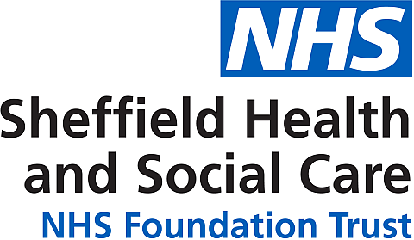

Request for Access to Health Records Under
- Data Protection Act 2018
- UK General Data Protection Regulation (UK GDPR)
- Access to Health Records 1990 (deceased patients only)

Please complete all parts in BLOCK CAPITALS and BLACK PEN and return to the address shown overleaf.

Details of Health Records to be Accessed

Patient

Surname

Forename(s)

Previous names, if any

Address

Date of birth

NHS number (if known)

If you are not requesting all your health information, please specify which services you require your records from or which particular documents you require, for example, a letter of diagnosis, or the dates between which you require your health records. Please provide any information you think will assist us to locate your records.

Details of Applicant
(If different from above)

Surname

Forename(s)

Address

Declaration
I declare that the information given by me is correct to the best of my knowledge and that I am entitled to apply for access to the health records referred to above under the terms of the Data Protection Act 2018 and UK General Data Protection Regulation (UK GDPR) / Access to Health Records Act 1990 (deceased persons only).

Please indicate which of the below is applicable:

- I am the patient

- I have been asked to act on behalf of the patient and attached his/her written authorisation (including an Independent Mental Capacity Advocate (IMCA))

- I have been appointed by the Court to manage the patient’s affairs and attach proof of my appointment

- I am the deceased patient’s personal representative and attach confirmation of my appointment

- I have a claim arising from the patient’s death and wish to access information relevant to my claim

Signed

Date

Verification of Identity

To confirm your identity, you will need to send us:

- A copy of one of the documents from the proof of identity list below

- A copy of one item from the proof of address list below

Please tick the appropriate box to indicate which document you have enclosed.

Proof of identity | Proof of address
- Current passport  - Current photocard driving licence  - Current EU driving licence  - HM Forces ID card | - Utility bill (no more than 3 months old)  - Council tax bill for current year  - Current benefit book or card, or original notification from the Department of Work and Pensions confirming rights to benefits.  - Recent bank statement (no more than 3 months old. You can blank out sort codes and account numbers. If you wish you can also blank out financial numbers on the bank statement.

If you are unable to provide one of these documents, please contact the Access to Records team at the Trust.

Deceased Patients Only

In addition to providing evidence of your identity, the applicant is required to provide evidence that you have the authority to access the health records of the deceased person.

Please tick the appropriate box to indicate which document(s) you have enclosed:
- Executor of the will: Grant of Probate

- Letters of Administration: Copy of such letters, certified by a solicitor, naming the applicant as having been granted letters of administration in respect of the deceased’s estate.
- Details of the grounds of a claim which the applicant is entitled to make, arising from the death of the deceased data subject.

When complete, please return this form by email to sct-ctr.accesstorecords@nhs.net

Alternatively, you can post it to:
Access to Records Team
Sheffield Health and Social Care NHS Foundation Trust 45 Wardsend Rd North, Sheffield S6 1LX

If you wish to submit your documents by email, a photograph from a mobile phone will suffice, if the image has the data on it that we have requested.

Once we are in receipt of the completed paperwork and your proof of identify we will process your request and contact you to let you know when you will receive your records.

If you have any queries, please contact the team using the email address above.

