Sheffield Adult Autism and Neurodevelopmental Service (SAANS)

**Understanding**

**Autism Spectrum Disorder (ASD) Course Workbook**

This booklet is intended to be used alongside the Understanding ASD course programme either online or at SAANS.

If you are not booked onto our live course and wish to complete the sessions independently, you can access pre-recorded course sessions online at: <https://www.shsc.nhs.uk/services/sheffield-adult-autism-and-neurodevelopmental-service-saans/understanding-autism-spectrum-disorder-group>

**CONTENTS**

Sessions 1 and 2

**Introduction**

**What is Autism Spectrum Disorder?**

(pages 3 – 14)

Session 3

**Anxiety**

(pages 15 – 22)

Session 4

**Sensory Processing**

(pages 23 – 30)

Session 5

**Social Interaction and Communication**

(pages 31 – 36)

Session 6

**Education and Employment**

(pages 37 – 41)

Session 7

**Recognising Your Strengths**

(pages 42 – 47)

**Sessions 1 & 2:**

**An Introduction to Understanding ASD**

**What will the course cover?**

* What is ASD?
* Anxiety
* Sensory issues
* Social interaction
* Education and Employment
* Recognising your strengths

We hope that the course will help you to gain more of an understanding of Autism Spectrum Disorder (ASD) and tools to help you manage any difficulties and enhance strengths that may accompany the diagnosis.

If you have any questions that are left unanswered by the end of the course, you are welcome to contact us to discuss these. Our contact details can be found at the end of this booklet.

**Hopes and Fears**

It can be useful to think about what you hope to gain from the course, and any fears you have about it. If, by the end of the course, these hopes haven’t been met, you can contact us to discuss further.

**Hopes**

**Fears**

**Being diagnosed with ASD**

Receiving a diagnosis can bring a wide range of emotions and thoughts, both positive and negative. Disclosing your diagnosis to others can also bring a wide range of reactions, both positive and negative.

Here are a few common reactions to receiving a diagnosis and when disclosing a diagnosis.

It can be useful to think about your reactions to receiving your diagnosis, and what reactions disclosing your diagnosis you have received from others, and you may find that your experiences are similar to many others’.

**Dismissive**:

“Everyone’s a bit Autistic, aren’t they?”

**Shame/Guilt**:

“Why didn’t I notice before?”

**Relief**:

“Things make more sense now”

**Regret**:

“I wish I’d been identified before”

**Anger**:

“Why me?”

**‘Coming to terms’**

**with the diagnosis**

**Happiness**:

“I like being Autistic”

**Shame**:

“I remember when I did this…”

**Fear**:

“How will life be in the future?”

**Denial**:

“I don’t have Autism”

**Sadness**:

“I’ll be like this forever”

**Dismissive:**

“Well, everyone’s a bit Autistic, aren’t they?”

**Shame/Guilt:**

“Why didn’t I notice before?”

**Denial**:

“Don’t be silly, of course you don’t have Autism! You can read / talk / make eye contact”

**Supportive**:

“How can we support you?”

**Disbelief**:

“You don’t look Autistic”

**Acceptance**:

“That makes so much sense!”

**Other people’s**

**reactions**

**to diagnosis**

**What is Autism Spectrum Disorder (ASD)?**

ASD is a neurodevelopmental condition, which means that people with this diagnosis have differences in how their brain has developed since before birth. This doesn’t mean that the brain has developed ‘wrong’, it just means that it has developed differently to the majority of the population.

ASD is a Spectrum condition: whilst people share certain symptoms or traits, the condition affects people many different ways.

There is still a lot of research to be done about what causes ASD.

**Terminology**

You may hear a few different terms when speaking about ASD or during this course. Here are some of the commonly used terms you may come across:

*ASD (Autism Spectrum Disorder)*

*ASC (Autism Spectrum Condition)*

*High Functioning Autism*

*Asperger’s Syndrome*

These terms are commonly used to describe the same diagnosis. As a service, we use Autism Spectrum Disorder (ASD) as this is the formal diagnostic term. However, these terms are often used interchangeably by professionals and the ASD community.

*Neurodivergent*

This term is often used to describe people who have a diagnosis of a neurodevelopmental disorder. This includes diagnoses such as ASD, ADHD, Dyslexia, Dyspraxia, Tourette’s Syndrome, and others.

*Neurotypical*

This term is used to describe people who are not neurodivergent; the majority of the population are considered to be neurotypical.

**Diagnosing ASD**

The diagnostic criteria we use to diagnose ASD contain the ‘Pentad of Differences’ as seen below.

Every person with ASD will display differences in each of these areas; these differences may be very subtle, or they may be obvious. They may cause difficulties for the individual, or they may present as strengths.

Even though every person with ASD display differences in these areas, each person will display them differently.

The following pages will describe each of these areas in more detail. As the course progresses, we will keep returning to these areas to discuss in more detail and provide tips and strategies to manage difficulties and enhance strengths associated with each.

**Social**

**Communication**

**Sensory**

**Sensitivities**

**ASD**

**Emotional**

**Regulation**

**Flexibility**

**of Thought**

**Social**

**Interaction**

**Social Interaction**

People with ASD may:

* Find it difficult to make friends and/or maintain friendships.
* Struggle to share other people’s enjoyment.
* Find unstructured social activities difficult but may thrive in certain activities tailored to their interests.
* Find it difficult to detect unspoken social rules, sometimes leading to social difficulties.
* Find it easier to socialise in small groups / pairs compared to larger groups.
* Find socialising exhausting and need time to rest and recover.

**Social Communication**

People with ASD may notice differences in:

* Processing and retaining verbal information, leading to difficulties keeping track of the topic of conversations.
* Engaging in small talk.
* Knowing when to talk, sometimes leading to unintentional interruptions.
* Understanding of irony, sarcasm, and jokes.
* Understanding non-verbal expression (e.g., facial expressions, gestures, eye contact).
* Needing to plan or script conversations in advance.
* Knowing how to comfort others when they are upset or distressed.
* Their preference of communication, and may thrive given the right method (i.e., online vs face to face).
* A tendency to talk for a long time about topics they’re interested in
* Being extremely honest, which can unintentionally cause offence.
* Struggle to understand ambiguous language or non-specific instructions.

**Flexibility of Thought**

People with ASD may notice they:

* Engage in repetitive behaviour, such as engaging in the exact same routine day to day.
* Have a set approach to everyday life, find it hard to change or try new things.
* May have an absorbing and narrow range of interests.
* Can spend an unusual amount of time dedicated to one task/activity, enabling them to complete it to an excellent standard or pursuing it at the expense of other activities that they need to do.
* May struggle to cope with being interrupted or be unable to return to an activity once interrupted.
* Thrive when in an environment that is familiar, predictable, structured, and safe.
* Think a very literal or black and white way, struggle to see other people’s point of view.

**Sensory Sensitivities**

People with ASD may:

* Experience over (“hyper”) or under (“hypo”) (or both!) sensitivity to noise, touch, taste, gravity, visual scenes/light.
* Engage in sensory seeking behaviours such as repetitive movements, looking at certain colours, listening to loud music.
* Engage in sensory avoidance behaviours such as avoiding certain places which are loud, bright, or colourful.
* Find it difficult to screen out sensory stimuli.
* Experience attention or concentration problems
* Be unaware of where their body is in space (proprioception)
* Struggle to understand their own internal signals (interoception)

**Emotion Regulation**

People with ASD may have difficulties with emotional regulation, which may lead to them:

* Finding it difficult to understand and label their own emotions.
* Feeling quite “flat” (low in energy, unmotivated)
* Having sudden eruptions of stress / agitation / excitement / anger
* Being either very quick to calm (minutes or even seconds) or very slow (days) to recover from heightened emotion.
* Triggers can be social interaction, sudden changes to plans or routine, having to go to a new place or sensory overload.

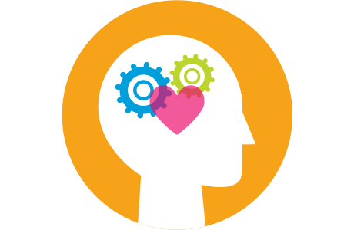

**Executive Functioning**

The cognitive processes that help us regulate, control, and manage our thoughts and actions, and to process information. It is controlled by the frontal lobe of the brain.

Executive functions help you manage life tasks of all types e.g., organising a holiday, developing a research project, writing an essay, or cleaning your house.

Often, when we think of problems with executive functioning, we think of disorganisation. However, organisation is only one of these important skills.

Some examples of problems with **Executive Functioning:**

* Planning and organisation
* Flexible thinking
* Monitoring performance
* Multi-tasking
* Solving unusual problems
* Self-awareness
* Learning rules
* Social behaviour
* Making decisions
* Motivation
* Initiating appropriate behaviour
  + Starting to do something.
* Inhibiting inappropriate behaviour
  + Stopping ourselves from doing something
* Controlling emotions
* Concentrating and taking in information

**Coping Strategies**

* Take step-by-step approaches to work.
* Have a weekly plan / schedule, somewhere easily visible.
* Ask for written directions with verbal instructions whenever possible.
* Plan and structure time to change and switch in activities.
* “Chunk” similar tasks together
* Managing time – schedule time to eat, go to the toilet, drink water etc.
* Create checklists and "to do" lists, estimating how long tasks will take.
* Make achievable “to do” lists.
* Set multiple alarms or reminders on your phone.
* Organise your space.
* Minimize clutter.
* Ask for help when you need it

**A Life in Balance**

****

What are some of your coping or thriving strategies?

Examples of activities that people with ASD may find helpful in managing stress can include spending time alone, gaining structure and predictability, engaging with passions and interests.

The environment may be calm, quiet, and ordered.

What helps you to balance out the stress?

What do you value in the neuro-typical world that may be worth the stress?

The neurotypical world is often chaotic, confusing, stressful, and difficult to navigate for a person with ASD.

However, this is where a lot of important activities, responsibilities and satisfaction can be gained e.g., socialising with others, spending time with family or achieving in work or education.

It can be easy to be overwhelmed by spending too much time in the neurotypical world!

**Session 1 and 2 questions:**

**You can write questions or comments below:**

**Session 3:**

**Anxiety and ASD**

Everyone experiences anxiety at some point in their lives – but anxiety affects people in different ways and to different degrees.

What works for one person doesn’t always work for others.

For some people, they can learn to manage anxiety without professional help. For others, it is a chronic condition that needs specialist input.

Anxiety is…

A **NORMAL EMOTION** – it helps us to cope with difficult, challenging, or dangerous situations.

It is **COMMON** – there are times when we all feel worried, anxious, uptight or stressed.

But anxiety becomes a **PROBLEM** when it stops you from enjoying normal life by affecting work, family relationships, friendships, or social life.

This is when **ANXIETY TAKES OVER** and things can feel overwhelming.

Anxiety is one of the most common mental health problems in the UK (and elsewhere).

Anxiety seems to be more common in people with ASD.

**What is Anxiety?**

Anxiety is the body’s alarm and survival mechanism. It works so well that it sometimes kicks in when it’s not needed e.g., when the “danger” is imaginary rather than real.

People who get anxious tend to go into scanning mode - where they're constantly on the lookout for danger, hyper-alert to any of the signals, and make it more likely that the alarm system will be activated.

When our body’s alarm system is activated, this can lead to a Fight, Flight, or Freeze response.

Fight can look like…

* Angry
* Defensive
* Shouting
* Tense

Flight can look like…

* Scared
* Avoiding
* Hiding
* Running away
* Procrastination
* Withdrawing

Freeze can look like…

* Overwhelmed
* Shut down
* Can’t respond / talk.
* Can’t make decisions.

**Why could Anxiety be more common or pronounced with ASD?**

The situations and thinking patterns that commonly trigger anxiety can naturally occur more often or cause more distress to people who have ASD. For example:

* + If situations, ideas, and other people’s behaviours don’t ‘fit’ with a fixed way of thinking.
  + If there are a lot of unexpected changes.
  + If misunderstandings and miscommunications frequently occur.
  + If situations feel overwhelming.

Often, people who have ASD can experience difficulties in identifying and recognising emotions which can cause early signs of anxiety to be missed, therefore making it more difficult to manage feelings of stress and anxiety before they become overwhelming.

**What factors may make people with ASD more likely to develop problems with anxiety?**

* Awareness of being different to others
* High trait anxiety (being naturally more anxious than others)
* Family tension
* Bullying and victimisation
* Adverse life events

**Signs of Anxiety: Psychological**

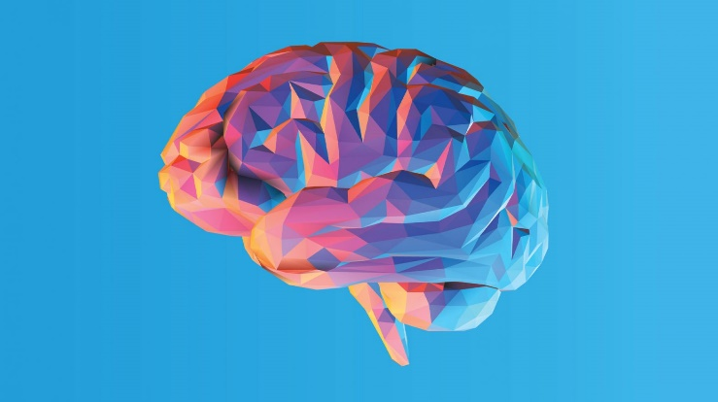

Easily losing patience.

Difficulty concentrating.

Thinking constantly about the worst outcome.

Difficulty sleeping.

Links with low mood & depression.

Becoming preoccupied with one subject.

**Signs: Physical**

* Shortness of breath.
* Tight chest.
* Dizziness or light-headedness.
* Palpitations.
* Muscle pain, especially head and neck pain.
* Wanting to go to the toilet.
* Shakiness.
* Sweating.
* Dry mouth – excessive thirst.
* Difficulty swallowing.
* Blurred vision.
* Butterflies or feeling sick.

**Signs: Behaviour**

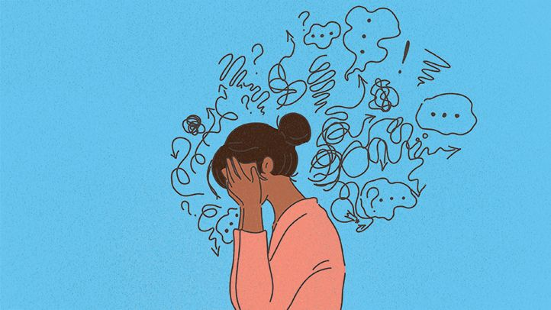

Avoiding people or places.

Not going out at all.

Going to certain places at certain times, e.g., shopping at smaller shops, at less busy times.

Only going with someone else.

Need an escape plan or to leave early.

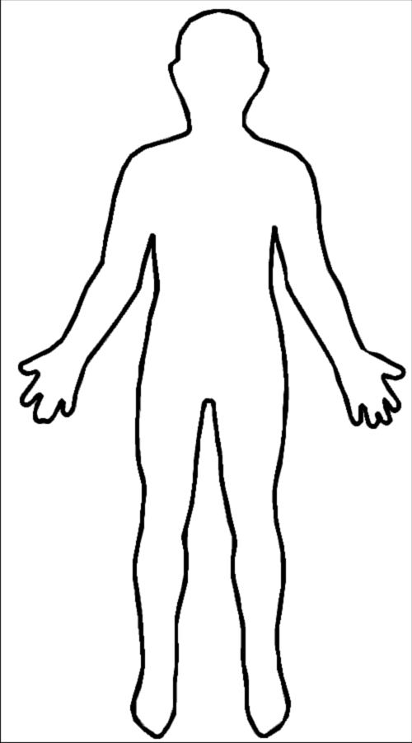

What makes me anxious?

How do I try to cope or avoid?

How do I try to cope or avoid?

What are my physical sensations?

What are my physical sensations?

What are my thoughts?

What are my thoughts?

**What can help?**

Learning to recognise your own signs of anxiety can be a good way to begin managing anxiety. Being aware of the early signs that you are becoming stressed or anxious means that you may be able to act to reduce these signs before they become unmanageable.

Start by completing the diagram on the previous page by reflecting on when you have been anxious in the past, and your triggers, thoughts, physical sensations and how you coped/avoided in this situation.

The lists below show some ideas of what activities can be useful to try for managing stress and anxiety. Some you can use ‘in the moment’ when you are in a stressful situation and notice your anxiety levels increasing, or day to day to generally improve your mental wellbeing.

**Physical Activity**

* Traditional exercise (sports, walking, gym, cycling, running)
* Creative activities (dancing, art, gymnastics, gardening)
* Sensory soothing activities (yoga, crafts, sensory equipment)

**Social Activity**

* Spending time with a family member or friend
* Socialising around your interests
* Balance with spending time alone
* Spending time with pets
* Using less stressful forms of communication

**Predictability**

* Visual schedules
* Visual cues or symbols
* Developing routine
* Learning more about your signs of anxiety

**Relaxation**

* Breathing techniques and mindfulness
* Visualisation
* Hobbies
* Listening to music
* Sensory soothing activities

**Useful Apps**

Brain in Hand – Autism support app

https://braininhand.co.uk/

Can be self-funded, via Access to Work scheme if employed, or Disability Student Allowance if in education.

Relax+ by Andrew Johnson – Relaxation app.

Free

Guided relaxation and music

Headspace – Mindfulness app

Free 10-day trial (can keep using this or purchase the full package)

Guided mindfulness practices

Balance

Useful app for meditation, stress and to help with sleep.

Often has offers on membership e.g., free use for the first year.

Calm

Contains lots of guided meditation to lower stress and anxiety

Does require a subscription to access most of the content.

Sleepiest

Has a range of podcasts, sleep meditations and relaxing soundscapes.

Has a subscription option, however plenty of free content.

**Additional Support**

Improving Access to Psychological Therapies (IAPT) are an NHS service who provide therapies to people with mental health difficulties such as anxiety.

You can access self-help information on their website or self-refer for an assessment via their website or by telephone.

Website: <https://iaptsheffield.shsc.nhs.uk/>

Phone: 0114 2264380

**Session 3 questions:**

**You can write questions or comments below:**

**Session 4:**

**Sensory Processing**

Everyone has different tolerance levels to sensation.

Our awareness of sensations can change with levels of tiredness, mood, hormones, illness, stress etc.

Unusual sensory processing has been widely reported in ASD; one study involving adults with ASD found that 94.4% of the ASD sample reported extreme levels of sensory processing differences.

**The Senses**

When we talk about the senses, we are referring to the 5 commonly known senses, and 3 lesser-known senses as described below.

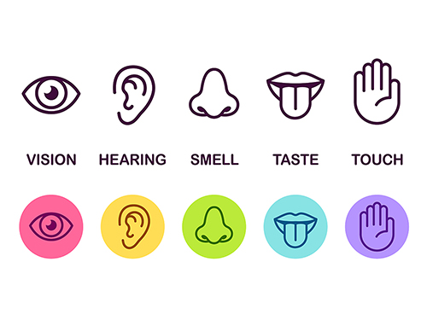

**Vestibular Sense**

* Tells you that your body is moving.
* It tells us about balance, movement & gravity.
* It co-ordinates the movements of the eyes, head, and body.

**Proprioception Sense**

* There are proprioceptive receptors in our joints, muscles, tendons, and ligaments.
* Our unconscious awareness of these sensations tells us where our body and limbs are positioned in space.

**Interoception Sense**

* Gathers information about what is happening inside our body and motivates us to do something about changes.
* For example: feeling hungry or full, needing the toilet, feeling nauseous, feeling pain.

**Hypo-sensitive or Under-responsive**

People who experience this type of sensory difference may find they:

* May be passive and find it difficult to engage in activity.
* May be slow to respond to environmental cues.
* May seek additional stimulation.

**Hyper-sensitive or Over-responsive**

People who experience this type of sensory difference may find they:

* May be easily distracted.
* May overreact or show extreme emotions.
* May actively avoid or block out sensory stimulation.

Most people find that they experience both of these types, perhaps depending on the sense they are using or other factors such as mood or tiredness.

**Problems with sensory modulation**

Difficulties with sensory modulation can be common with people who have ASD. These difficulties can cause:

* Difficulty ‘tuning out’ irrelevant stimuli or focusing on individual stimuli.
* Struggling to know when to stop / how much force to use / how much volume to use.
* May be over or under responsive.
* Can be overly emotional or lack emotional response.

**How does our sensory profile affect our behaviour?**

* Hypo-responsive (i.e., difficulty registering sensation) leads to sensory seeking.
* Hyper-responsive (i.e., very sensitive) leads to avoidance of sensory stimuli.
* Poor sensory modulation leads to swinging between avoidance and seeking behaviours and poor emotional regulation.

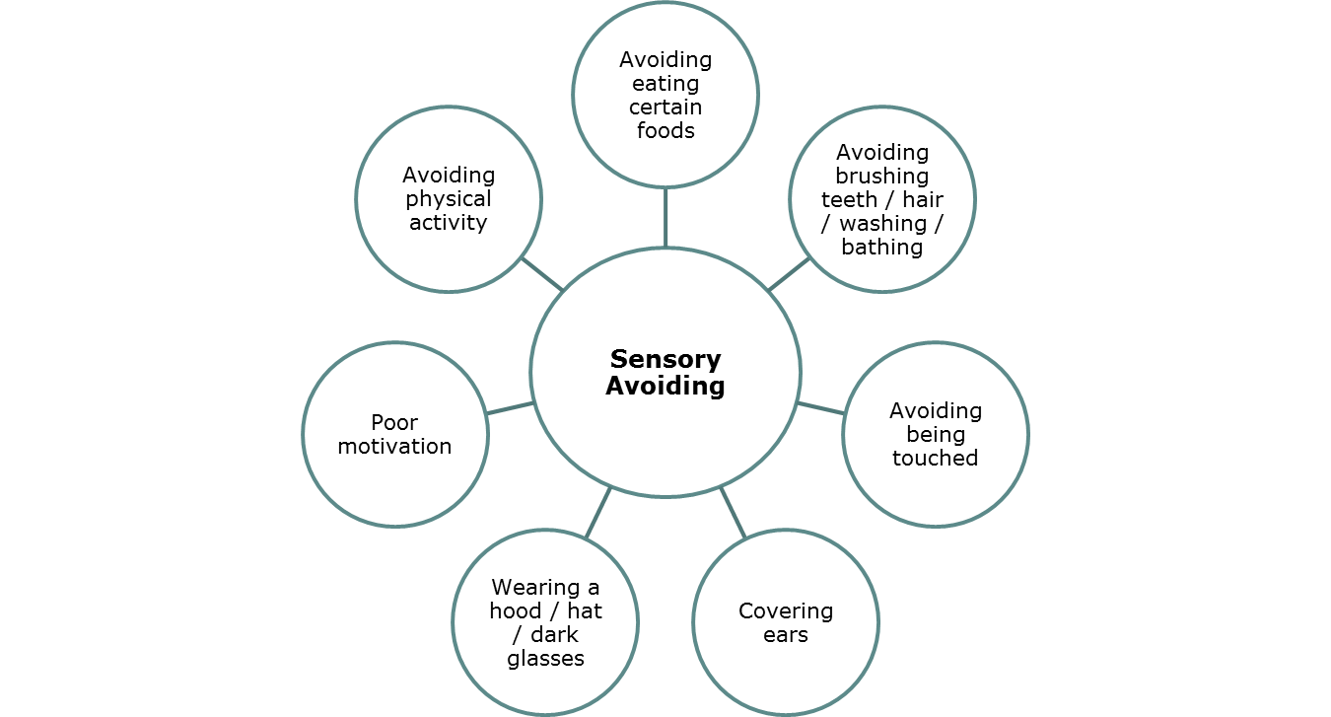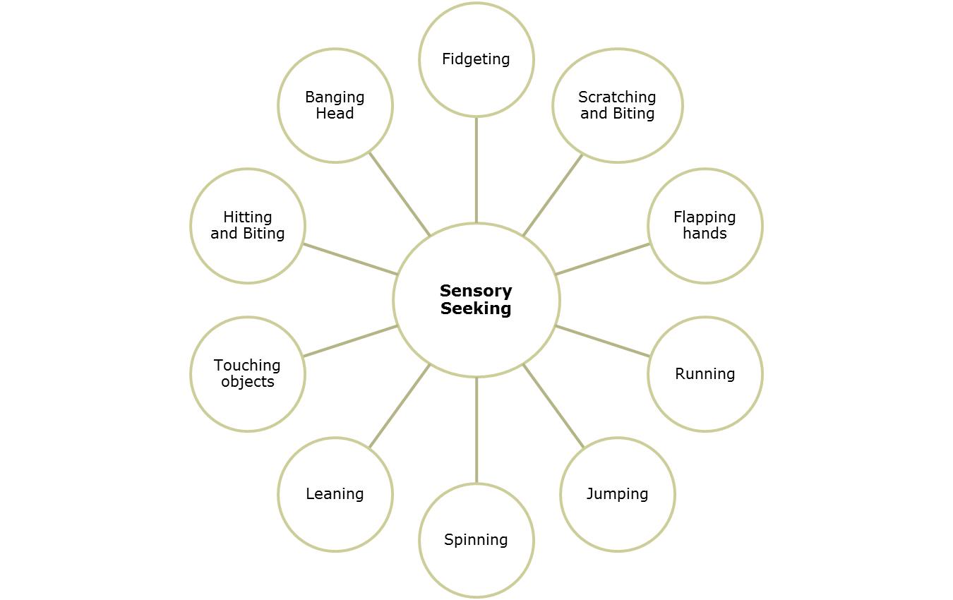**Examples of Sensory Seeking and Sensory Avoiding behaviours:**

**What helps?**

Ideally, we should be at an optimum arousal level where we are calm and alert. If we are too highly alert then this can cause overstimulation and feeling overwhelmed, if we are not alert enough then this can cause low moods, fatigue, and issues with motivation.

It can be useful to try to identify signs that you are too alert or not alert enough and take action to calm or alert depending on what you need. An effective way to do this is to utilise your sensory differences to alert/calm as needed. Please see examples of calming or alerting activities on the following pages to try.

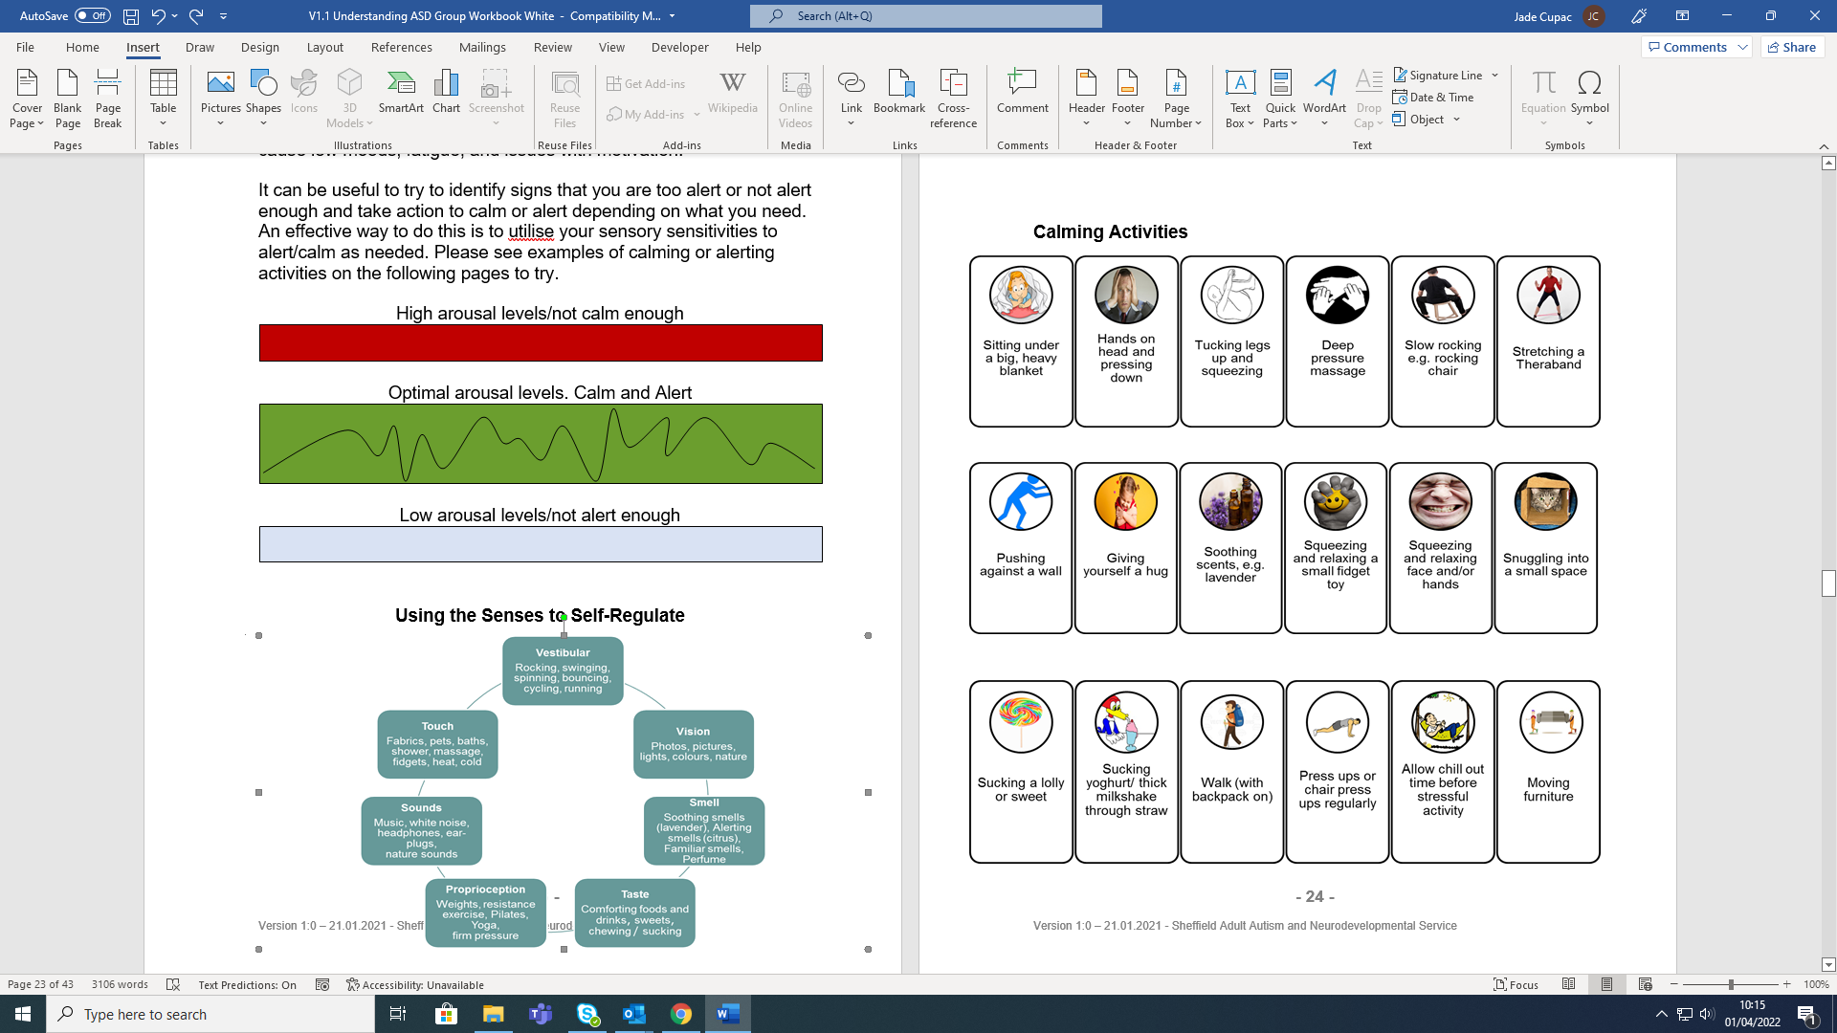

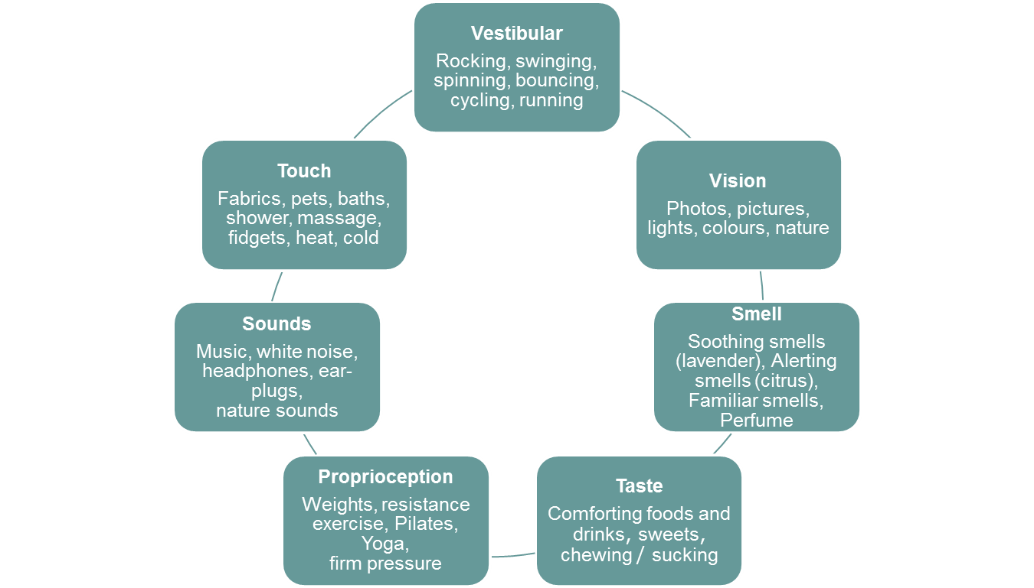**Using the Senses to Self-Regulate**

**Calming Activities**

* Tight bear hugs
* Wrap yourself up in a blanket (can be weighted)
* Carry a heavy backpack
* Pushing a trolley in the supermarket
* Chewing gum
* Swimming or walking in water
* Repetitive actions (rocking or swinging)
* Yoga poses, sitting on the floor
* Squeeze play-dough
* Give yourself a hand massage
* Soft, loose clothing with no labels
* Choose familiar, sweet flavours
* “Safe textures”
* Dim lighting, side lamps or fairy lights
* Reducing glare from screens
* Minimise clutter.
* Black-out blinds or curtains
* Wear an eye mask to sleep.
* Use ear defenders or noise reducing earplugs (e.g., loops)
* Have a quiet space to go to when needed.
* Listen to white noise or nature sounds.
* Use unperfumed toiletries or calming scents such as vanilla, rose or lavender.
* Have a familiar perfume or scent in a diffuser.

**Alerting Activities**

* Playing loud music
* Listening to the same songs on repeat
* Jumping on a trampoline
* Blowing a kazoo or whistle
* Climbing
* Dancing
* Riding bikes
* Swimming
* Sitting on an exercise ball or wobble seat
* Eating popping candy
* Sleep with a night light
* Light up objects, bubble tubes
* Disco balls or lava lamps
* Cooking with strong smells
* Scents such as citrus or peppermint
* Drink flavoured tea
* Adding extra spice to food
* Sour sweets
* Citrus flavoured food or drinks
* Crunchy, ridged crisps

**What are your own calming and alerting activities?**

**(you could include examples from other people)**

**Helpful Tools**

It can be useful to use tools such as diaries, calendars and a self soothe kit to note down what would be helpful, and to plan calming/alerting activities into your routine or around potentially stressful events. You could use your own tools, or use our examples below:

|  |  |  |  |  |  |  |  |
| --- | --- | --- | --- | --- | --- | --- | --- |
|  | **Monday** | **Tuesday** | **Wednesday** | **Thursday** | **Friday** | **Saturday** | **Sunday** |
| 9am | Shower | Shower | Shower | Shower | Shower |  |  |
| 11am | Cup of tea |  | Cup of tea |  | Cup of tea | Karate | Gardening |
| 1pm | Lunchtime walk | Use sensory toy | Lunchtime walk | Talk with colleagues | Lunchtime walk | Chill time |  |
| 3pm |  | Eat crunchy snack |  | Rest in dark room |  | Meet with a friend |  |
| 5pm | Suck a sweet driving home | Listen to music driving home | Listen to podcast driving home | Listen to music driving home | Wrap-up in poncho on sofa | Chill time | Bath |
| 7pm | Yoga | Exercise |  | Karate | Bath with candles | Shower |  |

**Example:**

**Your own:**

|  |  |  |  |  |  |  |  |
| --- | --- | --- | --- | --- | --- | --- | --- |
|  | **Monday** | **Tuesday** | **Wednesday** | **Thursday** | **Friday** | **Saturday** | **Sunday** |
| 9am |  |  |  |  |  |  |  |
| 11am |  |  |  |  |  |  |  |
| 1pm |  |  |  |  |  |  |  |
| 3pm |  |  |  |  |  |  |  |
| 5pm |  |  |  |  |  |  |  |
| 7pm |  |  |  |  |  |  |  |

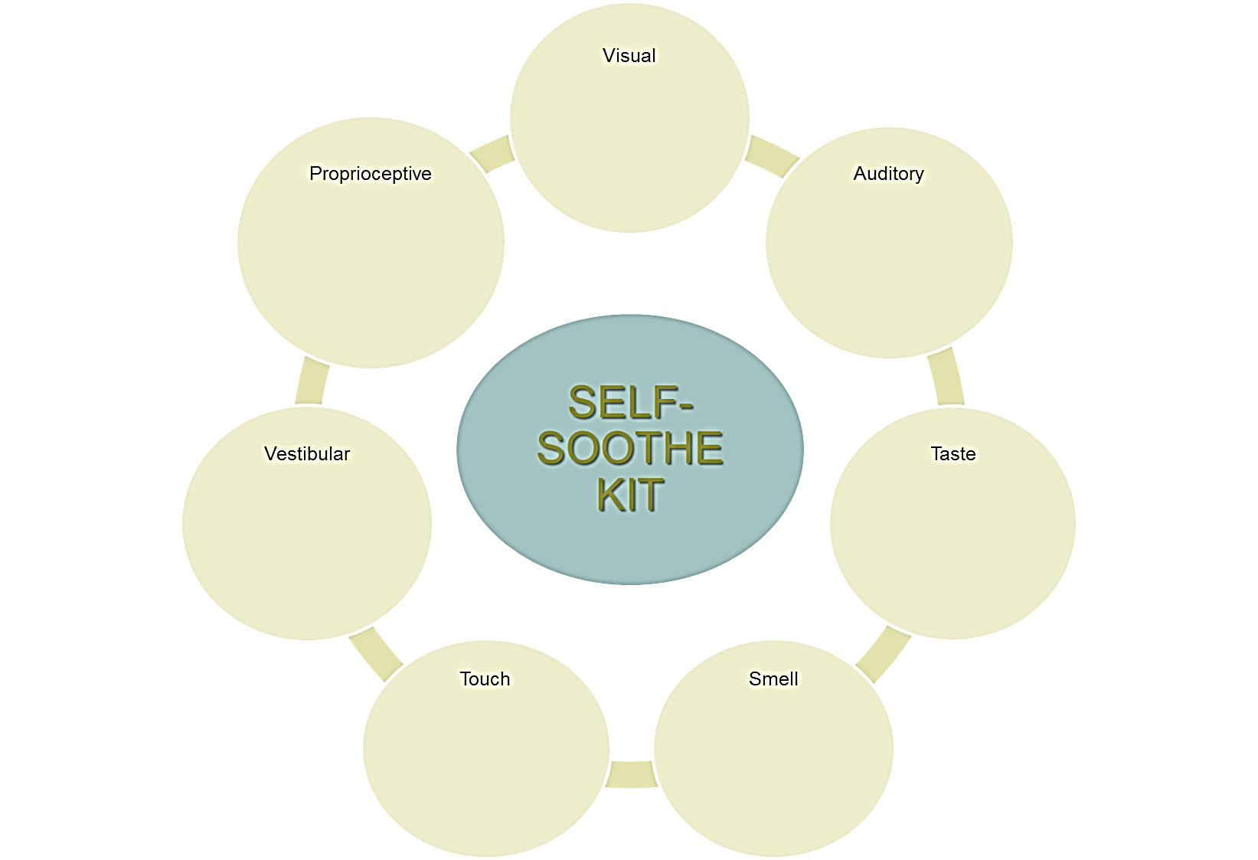

**Session 4 questions:**

**You can write questions or comments below:**

**Session 5:**

**Socialising and Communication**

**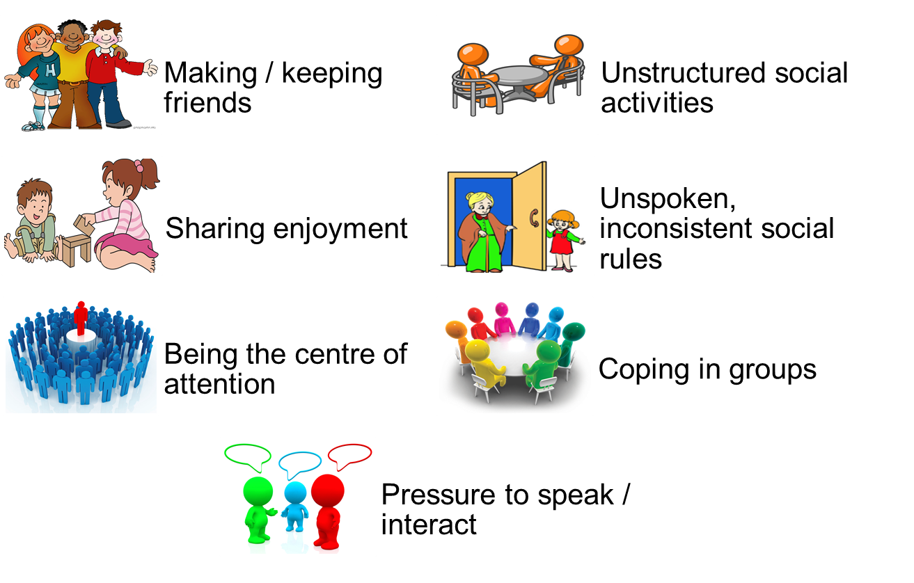**

**Difficulties in social interaction**

People with ASD often have difficulties when socialising. These can be caused or made more difficult by differences in communication and interaction skills, such as:

* A difficulty in processing and retaining verbal information which can lead to forgetting what you or the other person was saying.
* Finding small talk difficult (talking about nothing versus talking about something).
* Finding it difficult to know when to talk, sometimes leading to unintentional interruptions or feeling unable to say what you would like to.
* Finding it difficult to understand irony, sarcasm, and jokes.
* Finding non-verbal expression difficult to understand or uncomfortable (e.g., facial expressions, gestures, eye contact).
* Being misunderstood or misunderstanding others.

**Anxiety and Socialising**

* Making friends and socialising involves communication at different levels.
* Some people find they are good at socialising in some ways, but they can struggle in other ways. For example, some people enjoy socialising online but find face to face interaction difficult and stressful.
* The more stressed you are, the more difficult it is to communicate and make friends.
* High levels of stress and anxiety can eventually lead to avoidance and isolation, which in turn can lead to difficulties with mental health such as depression.

**What can help?**

Thinking about your social experiences, including what works well and what doesn’t work as well, can be a good starting point to helping social interaction feel more successful and enjoyable.

Identifying what level of socialising is enjoyable for you can be helpful. Sometimes you may want to push yourself to social interaction that may be more stressful, which can be a useful way to get used to managing that situation. But this is your choice.

The table below shows ‘levels of socialising’, from lower stress activities to higher level. Have a look at this and identify what level you’re comfortable at now, and what level you would like to be at. You can also change how you socialise depending on your mood at the time, for example if you’re feeling highly stressed you may want to socialise at level 1 or 2.

**DO WHEN HIGHLY STRESSED EASIER WHEN CALM AND RELAXED**

**Level 1: Being alone.**

**Relaxing**

**Level 2: Being alongside.**

**Slightly Stressful**

**Level 3: Being with**

**Moderately stressful**

**Level 4: ‘Hanging out’**

**Very stressful**

Certain people may only be able to cope with being on their own or need to isolate themselves if stressed e.g., playing computer games by themselves, reading, walking.

Some people enjoy simply being alongside other people without direct interaction while doing an enjoyable activity e.g., watching football in the pub, sport, watching a film together, walking in the countryside.

Some people enjoy doing a focused activity with others e.g., games, chatting about an interest or any other interest they enjoy.

Some people, in the right circumstances, can enjoy simply spending time with people, making small talk, for the sake of it without a focused activity.

**Social Battery**

The social battery can be a useful tool to manage your energy levels when you are engaging in activity that can be stressful.

To use this tool, consider and list what activities may ‘drain’ your battery (or energy levels), and what may ‘fill’ your battery. When you are starting to feel overwhelmed or drained look at your ‘fills’ list and choose an activity. This tool is about bringing balance into your life to make difficult activities more manageable.

For example: if you are going to an event that you know is going to be stressful for you, such as a social event, plan some time before, after, and during (if possible) to engage in a ‘filling’ activity, such as spending time alone in a dark room, going for a walk, or engaging in a hobby.

**The Social Battery**

****

Things that can **drain** our battery:

Socialising:

Communicating:

Sensory stressors:

Unpredictability:

Psychological stressors:

Other stressors:

Things that **recharge** our battery:

Isolation:

Alternative ways of communicating or socialising:

Sensory activities:

Structure/routine:

Interests:

Psychological techniques:

Other relaxing activities:

**Other Helpful Tips**

**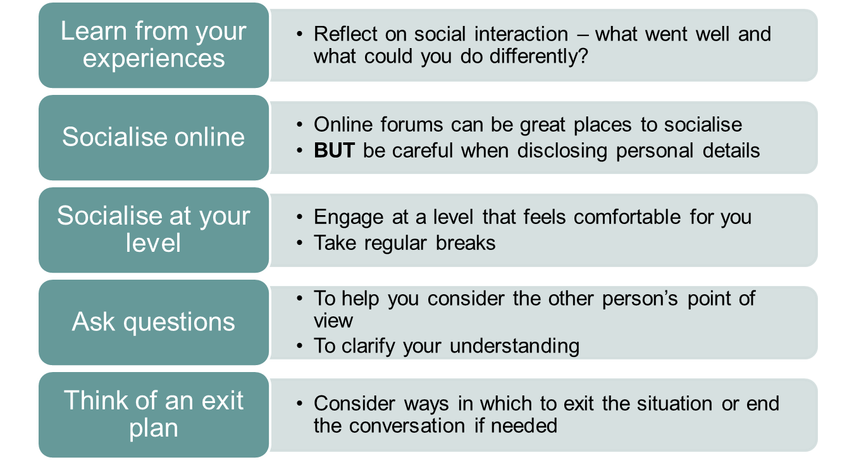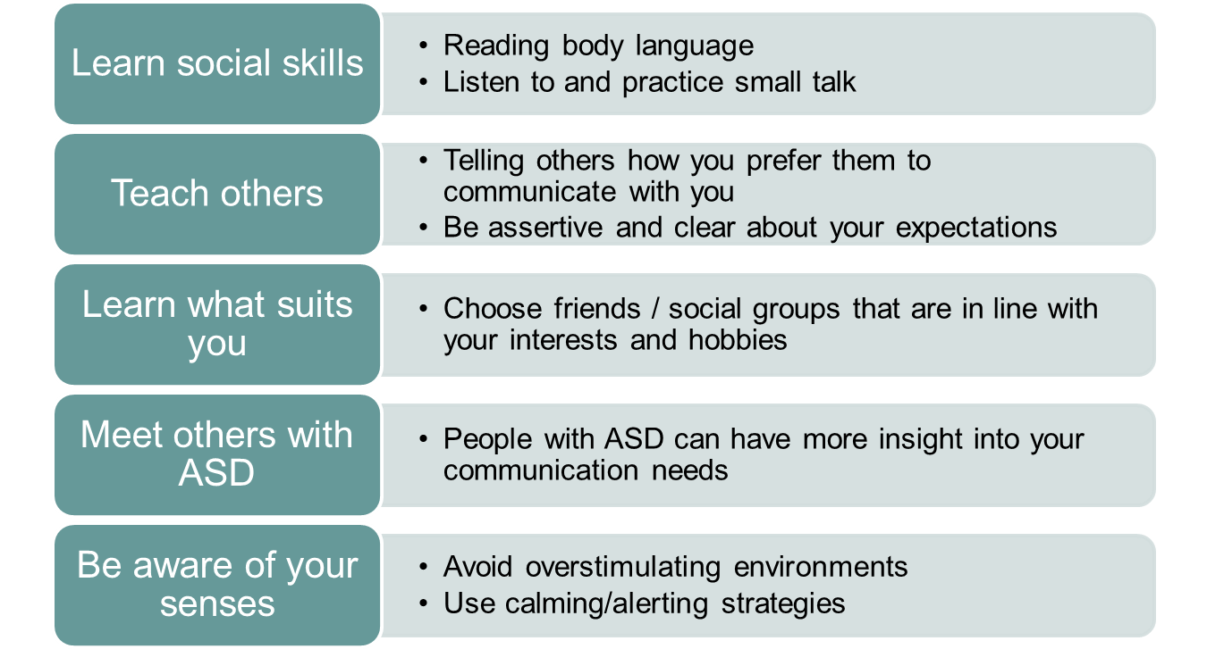**

**Joining a social group**

Social groups can be…

* An opportunity to meet others and socialise in a safe environment.
* A good place to practice skills.
* Either focused on one activity (i.e., drama) or a few different activities (i.e., trips to the cinema or bowling).

How to find a group…

* Search for social groups online at:
* https://www.autism.org.uk/ directory
* https://sheffieldautisticsociety.org.uk/activity/adult-aspergers-group/
* Contact the Autism Helpline (NAS): 0808 800 4104

**Sheffield Autistic Society**

The Sheffield Autistic Society is a local parent and peer-led support group for autistic people and parents and carers of autistic people of all ages. They hold a variety of events and group activities, such as:

* Sheffield Adult Asperger Group (fortnightly zoom meetings)
* Photography Group
* Art Group
* Snooker Club
* Dance and creative workshops
* No Social Pressure Group for Adults on the Autism Spectrum
* ACCTing Out (social group for autistic young adults)

**A Team Social Group**

A diverse group of adults on the autistic spectrum who live in Sheffield and meet socially on a regular basis.

* Newly diagnosed Women’s Group
* Drama workshops
* Pottery
* Photography
* Bird watching
* Cookery
* Ice skating, bowling, crazy golf Trampolining
* Cycling
* Meals out together
* Theatre Trips
* Yoga, swimming and Keep Fit
* Climbing
* Day Trips

**Useful Websites for more information:**

* The National Autistic Society -<https://www.autism.org.uk/socialskills>

**Session 5 questions:**

**You can write questions or comments below:**

**Session 6:**

**Education and Employment**

**Your rights**

As a person with a diagnosis of ASD, you are classed as having a disability under the Equality Act (2010) and this comes with legal protection.

**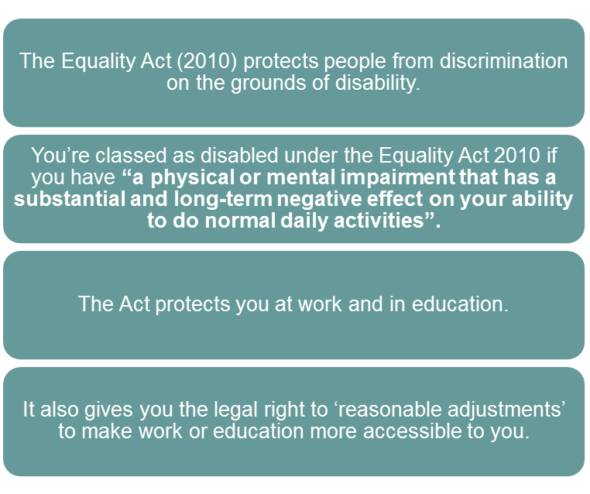**

A person with disabilities (including ASD) can ask for reasonable adjustments from their employer if any aspects make it much more difficult for them to do their job because of their disability than it would for a non-disabled person:

1) the working arrangements

(e.g., the hours or the method of working)

2) the building or place where you work

(e.g., steps or doorways, lighting, noise levels)

Reasonable adjustments must be made unless the employer can adequately justify that the request is ‘not reasonable’.

**Reasonable Adjustments**

**How can the workplace or place of education support someone with ASD?**

These are a few examples, but you can request any adjustment that you feel would improve difficulties that are due to your ASD.

* Make instructions concise and specific.
* Provide a well-structured routine.
* Clarify expectations and understanding.
* Provide sensitive but direct feedback.
* Provide 1:1 feedback and reviews.
* Educate other staff.
* Offer clear and structured training.
* Use a work mentor or buddy.
* Give advance notice of changes.



**Disclosing your ASD**

* For an employer to have a duty to put in place reasonable adjustments, the person must tell their employer of their disability.
* Notifying Occupational Health is now seen as the equivalent to notifying the employer.
* If you do not want your whole team to know, you could just tell your line manger and/or the human resources team.
* However, telling your team might make it easier for them to support you.

**Organisations who can offer support for you in work or when trying to find work:**

|  |  |
| --- | --- |
| 488135_360885384030571_1854097507_n (2) | **Spectrum E**  Contact: Shuchi Harris  Email: [spectrum3e@gmail.com](mailto:spectrum3e@gmail.com)  Tel: 07832 037122 |
| Austism Centre for Supported Employment | **The Autism Centre for Supported Employment**  Tel: 07399 122268  Email: [autism.centre@yahoo.co.uk](mailto:autism.centre@yahoo.co.uk) |
| Big Ambitions | **Big Ambitions**  Email: [enquiries@bigambitions.org.uk](mailto:enquiries@bigambitions.org.uk)  Tel: 0114 276 0039  <http://bigambitions.org.uk/>  **Autism Plus**  Email: [info@autismplus.co.uk](mailto:info@autismplus.co.uk)  Tel: 0114 384 0284  <https://autismplus.co.uk/> |
| sf-logo-e1448877744832 | **Sheffield Futures**  Tel: 0114 201 2914.  Email: [enquiries@sheffieldfutures.org.uk](mailto:enquiries@sheffieldfutures.org.uk)  [www.sheffieldfutures.org.uk](http://www.sheffieldfutures.org.uk/) |
| [suitlogo2](http://www.thesuitworks.co.uk/) | **The Suit Works**  Tel:  07468 464776  Email: [info@thesuitworks.co.uk](mailto:info@thesuitworks.co.uk)  [www.thesuitworks.co.uk/](http://www.thesuitworks.co.uk/) |
| logo | **Voluntary Action Sheffield (VAS)**  Email: [vc@vas.org.uk](mailto:vc@vas.org.uk)  Tel: 0114 2536649 [www.sheffieldvolunteercentre.org.uk](http://www.sheffieldvolunteercentre.org.uk/) |
|  | **Citizens Advice Service (Mental Health)**  Email: [mentalhealth@sheffieldcitizensadvice.org.uk](mailto:mentalhealth@sheffieldcitizensadvice.org.uk)  Tel: 0114 271 8025 |
| [Jobcentre Plus](https://www.gov.uk/) | Speak to a job coach about getting disability support through **Work Choice** or **Access to Work** Bailey Court Jobcentre Plus: 0114 2033 168  Cavendish Court Jobcentre Plus: 0114 259 0154 |

**Support with Education**

* Many colleges and universities provide support for students with ASD, which can include:
  + Individualised packages of support
  + Use of assistive technology
  + Support worker services
  + Specialist advice and guidance

**Bullying and Harassment in Employment and Education**

Bullying and Harassment can be defined as:

“*When one person, or a group of people, intentionally cause harm to someone else and behave in a way that is deliberately offensive and unkind towards them. For example, a bully might make jokes about an individual's disability, or make rude remarks about someone's sexual orientation*.”

**Bullying can be direct or indirect.**

**Examples of direct bullying:**

* Rude remarks.
* Jokes or remarks about your disability.
* Insulting you in what they are saying to you or the way they are behaving towards you.
* Overbearing supervision or other misuse of power or position.
* Unwelcome sexual advances - this could be touching you or standing too close to you while showing or displaying something that you find offensive.
* Humiliating you in front of other colleagues.
* Physical abuse.

**Examples of indirect bullying:**

* Not being put forward for training or promotion.
* Persistently criticising your performance.
* Setting you tasks or deadlines that you are never going to be able to meet.
* Leaving you out or not inviting you to team social events.
* Spreading malicious rumours about you.
* Making uncalled for comments about your job security when you have been working perfectly satisfactorily.

**Bullying can occur…**

* Face-to-face
* In emails or other written documents
* Over the phone
* By being unfairly monitored for something when none of your colleagues are being singled out for the same kind of treatment. This means you are being supervised in a way that no-one else is, so you are being treated differently.

**If you think you are being bullied:**

* Try to talk to someone.
* Keep a diary of what is happening.
* Use your union.
* Contact specialist services such as
  + Sheffield Occupational Health Advisory Service
  + Citizens Advice Bureau

**Session 6 questions:**

**You can write questions or comments below:**

**Session 7:**

**Recognising Your Strengths**

For many people, ASD is considered a naturally occurring variation in brain development, which is a difference rather than a ‘disability’. Often, difficulties with ASD come from living in a world that is not suited to many of the differences that occur from having ASD. Although, for many people, ASD can cause a lot of challenges and difficulties, this diversity can also come with unique strengths.

Recognising these strengths and using them in a positive way is a very important part of understanding your own ASD.

**The Pentad of Strengths**

The areas where we commonly see differences in people who have ASD can often show positive and amazing strengths, as well as causing difficulties. Below are a few areas where strengths may lie.

**Social**

**Communication:**

-Can be knowledgeable and talk

passionately about interests.

Social

**Interaction:**

- Can thrive in the right social situation.

- Can engage well in specific activities.

**Flexibility of Thought:**

-Can be passionate about certain topics.

- Can be concentrate on tasks and activities for significant lengths of time.

**ASD**

**Emotion**

**Regulation:**

- Higher levels of emotional empathy.

**Sensory**

**Sensitivities:**

- Excellent attention to detail

- Heightened appreciation i.e., for art or music.

**The Brain and ASD**

It is widely believed that one of the reasons why people with ASD experience the world differently is due to differences in brain development. These differences are what can cause some of the great strengths associated with ASD, as well as the difficulties. Some of these differences are explained below:

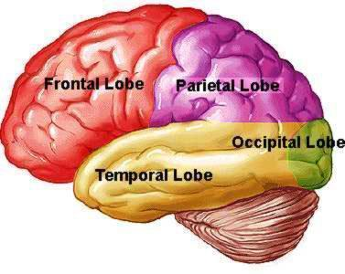

**Parietal Lobe:**

* Greater logical and visuo-spatial abilities (e.g., puzzles, maps, maths, or building things such as Lego).

**Frontal Lobe:**

Executive functioning differences:

* Longer attention span for interests.
* Difficulty changing tasks.
* Understanding others can be harder.
* More easily distractible.
* Difficulty moderating emotions (stopping them from getting too high or too low).
* Difficulty with planning and organization.
* Difficulty with inhibiting behaviours.

**Temporal Lobe:**

Greater abilities in:

* Remembering and recalling facts.
* Visual memory.
* Visual processing (good eye for detail).

**Memory**

* Short-term memory for recent events and instructions can be difficult.
* Long-term memory, especially for facts / statistics, and be very good.

**Attention to Detail**

* It has been suggested that people with ASD process information differently, this ability is called systemising and helps with:
  + Identify patterns and rules in systems (music, language, weather etc).
  + Paying greater attention to smaller details.
  + The ability to hyper-focus, which when well directed can mean lots of things can be achieved in a short space of time.

**Resilience**

* Some strengths, such as being more resilient, come as a consequence of living with ASD and the challenges this may bring. For example, having to manage sensory sensitivities may lead to the development of more effective coping strategies which may help when managing other situations.

**Communication**

* People with Autism are often straight talkers!
* Communication tends to be around exactly what is being said – without hidden agendas.
* They can be good at talking about interests in detail.
* This can depend on if the person is using their preferred form of communication (such as face to face, online or over the phone).



**Social Interaction**

* People with ASD are often not bogged down by social rules.
* They can sometimes be less judging of others based on race, gender, and sexuality.
* They can feel more comfortable within groups outside of the norm, e.g., certain sub-cultures or with other people with ASD.

**Emotionality**

* Some people with Autism can direct their hyper-emotionality into creative or other useful pursuits.
* Having very strong, heightened emotions can be a strength of some autistic people.
* However, it can also be helpful if you are able to remain logical / rational in emotive situations.

**Other Positive Attributes**

* Good problem-solving skills.
* Determination.
* Increased self-awareness.
* Coping strategies.
* Being aware of their own triggers.
* Organisational skills.



**What are my Strengths?**

Thinking about the strengths we have discussed, which ones do you think apply to you?

Can you think of anything else we haven’t mentioned?

In what situation is it easiest for you to use these strengths/ how often do you get to use them?

**Session 7 questions:**

**You can write questions or comments below:**

***Thank you for attending.***

If you have any further questions about any part of the course, please let us know via:

**Phone:** 0114 2716964

**Email:** SAANS@shsc.nhs.uk